1WQ

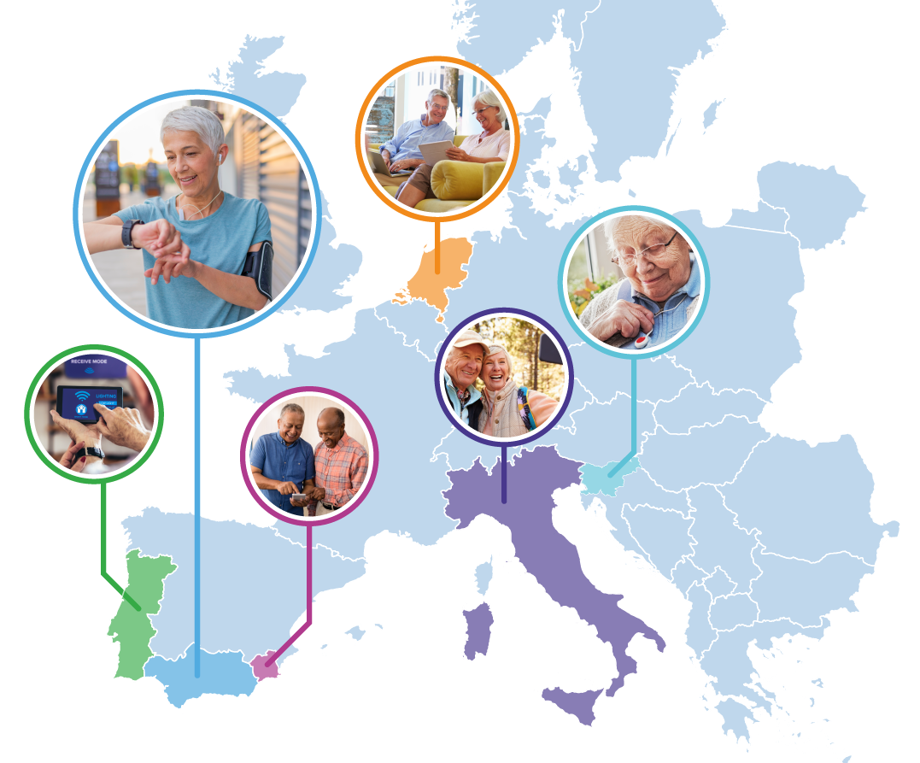

PILOTS FOR HEALTHY AND ACTIVE AGEING
Grant Agreement: 857188

Second Pharaon Open Call

Contents

1 Introduction 4
1.1 Overview of the Pharaon Project 4
1.2 Pharaon general and specific objectives 4
1.3 Pharaon Pilot Challenges 5
1.4 Pharaon Pilots 8
2 Scope of the Second Open Call 8
2.1 Specific Actions of OC2 8
2.2 Indications for applicants 9
2.3 OC2 challenges 11
3 Pharaon Hub and integration requirements 13
3.1 Overview of integration and evaluation requirements 13
3.2 Detailed requirements for SA3 integrated technology 13
3.3 What we provide for SA3 integration 15
3.4 Planning of OC2 winner projects 15
4 Applicant consortium size and available budget 17
5 Ethical considerations, data management, and quality control 17
6 Eligibility criteria 18
6.1 General provisions (admissibility of submitted applications) 18
6.2 Applicant eligibility 18
6.3 Eligible activities 19
7 Exclusion criteria 20
8 Application process 21
8.1 Open Call Procedures for Submission, Evaluation, and Grant Management 21
8.2 Timetable 21
9 Evaluation process 21
10 What’s next for selected proposals? 22
10.1 Agreement process 22
10.2 Technical evaluation 23
11 Funding scheme 23
11.1 Administrate requirements of successful applicants 23
11.2 Funding scheme and rules 23
11.3 Payments 24
11.4 Eligibility of Costs 24
12 Intellectual property rights 25
13 Support for applicants 25
14 Right to Reject Proposals 26
▪ Appendix 1 Application Submission Guide 27

Figures
Figure 1. Planning of OC2 winner projects 19
Figure 2. Pharaon Open Call evaluation process 24

Tables
Table 1 QoL and Sustainability KPIs, methods and timing 10
Table 2 Approximate Open Call timeline 21

Introduction

Overview of the Pharaon Project
Pharaon (Pilots for Healthy Active Ageing) is a Horizon 2020 project to improve the dignity, independence, and wellbeing of older adults by providing enhanced smart and active living solutions. The project has created a set of customizable and interoperable platforms that provide advanced services, devices, robotics, IoT tools, artificial intelligence, data management, cloud computing, smart wearables, and analytics. The Pharaon platforms are built on mature state-of-the-art platforms and integrate existing technologies.
There are 6 pilots spread across 5 countries and each pilot has different use cases and needs, providing an opportunity to show the strength of the Pharaon platforms under real and varying conditions.
Pilots foresee the concrete involvement of older adults as users and both informal and formal caregivers as providers. Pilots address relevant use cases that demonstrate the added value of the Pharaon Ecosystem, while offering quality of life improvements to users.

Pharaon general and specific objectives
The overall objective of the Pharaon project is to provide support for Europe’s ageing population by integrating digital services, devices, and tools into open platforms that can be readily deployed while maintaining the dignity of older adults and enhancing their independence, safety, and capabilities. The project uses a range of digital tools including connected devices (e.g., the Internet of Things, IoT), artificial intelligence, robotics, cloud and edge computing, smart wearables, big data, and intelligent analytics that are being integrated to provide personalised and optimised health care delivery.
The overall objective will be achieved by setting and reaching several Specific Objectives (SOi), classified in two subsets: development (SO1-4) and demonstration (SO5-10).
- To identify the current state of interoperability between widely used platforms and partner solutions and solutions from third parties involved at Pharaon at the open calls, then develop and implement a generalized integration protocol.
- To implement personalized analytics that provide older adults and their caregivers with the most pertinent physical and mental health as well as wellbeing information.
- To demonstrate the feasibility of integrating the Pharaon platforms with existing systems related to intelligent transport and mobility, energy optimization, and smart cities.
- To ensure user-friendly human-computer interaction modes that addresses various capacity limitations, provides rapid access to useable information.
- To systematically implement, test and validate the Pharaon platforms at a pre-validation stage providing early feedback to the function and usefulness of these platforms and their integrated technologies.
- To involve new stakeholders and their technologies, products, or services in the different ecosystems through the launch of open calls.
- To pilot the platforms in 6 different sites from 5 countries, with a scope of thousands of users including older adults, formal, and non-formal caregivers.
- To prove the efficacy of the platforms by applying standards and proven metrics, such as MAFEIP1.
- To widely share, disseminate and exploit the progress and outcomes of the project with a broad audience of caregivers, older adults, policy makers, the public, and academics.
- To liaise and inform standardization bodies to align Pharaon solutions to the most recent standardization efforts in the field and to contribute to those standards with the acquired technical and practical knowledge.

Pharaon Pilot Challenges
Each pilot has chosen a set of Pharaon Challenges (PCHs), and thus, it has selected its own set of technologies to address them. The PCHs are:
- PCH1 - The behaviour and the approach of elderly to friendly technological devices
Compared to younger adults, older adults use the internet less and are less likely to have a smart phone or device. Some preliminary surveys seem to indicate that this is changing, but still reflects the low adoption of these technologies. So, all solutions should be targeted to their specific audience and a suitable approach to training and support should be present.
- PCH2 - Health status definition and its progress over time.
A complex question related to older adults is how to define their health status in an objective, automatized and reproducible manner. Solutions that follow a common approach, such as the Comprehensive Geriatric Assessment approach based on the collection and analysis of data at scale will support health care providers and improve the wellbeing of older adults. For example, Heart failure is the most common disease in older people. Heart failure is the leading cause of hospitalization, accounting for 3% of all hospital admissions and approximately 2.5% of the total healthcare costs. In 2010, heart failure constituted 3% of all deaths in men and 10 % in women. A unified approach that links monitoring solutions with older adults’ information could improve safety and efficiency of healthcare by increasing the availability of older adults’ information and reducing the unneeded interaction between older adults’ s and doctors. The best solutions should promote self-care in older adults’ s by providing them and their caregivers with health education and training, and other social and health resources.
- PCH3 - Non-Intrusive Monitoring and Alarm Triggering.
Continuously monitoring environments, older adults’ or residents, and their habitats allows us to estimate the typical levels of activity of older adults’ at home. Once the typical activity levels are identified, any deviation from these can warn us about a potential incident, such as a fall. These warnings are constantly monitored by professionals who are familiar with clinical and social (family, neighbours, caregivers) circumstances of the older adults’ and know who to contact in case of emergency. This approach is especially useful for vulnerable older adults’ who live alone, allowing non-intrusive surveillance that does not limit their autonomy or their privacy. It can also reduce costs of subcontracting beds in residences. By reducing the rates of institutionalization of older adults, risks and costs related to transmissible infectious and resistant diseases can be avoided or mitigated. Energy consumption, air quality, direct activity, and use of other devices can be monitored this way. Alarms can relate dangerous conditions, falls, sustainability indicators, security threats, and can help communicate the needs of older adults more clearly (sometimes before they are requested or needed such as in the case of a heart attack). The application of worn and environmental sensors or related tools can significantly contribute to this challenge.
- PCH4 - Promote social cohesion.
Social cohesion is a major concern internationally. The type of change that can best contribute to competitiveness, employment and social inclusion involves forms of multilevel and intersectoral governance for the territorial integration of policies. Mobility is a vital factor of social inclusion in society and an important precondition for a satisfying quality of life in while ageing. Reduced mobility leads to isolation and dependence can have a devastating effect on their self-esteem. Barriers related to cost-effective mobility should be considered along with other solutions to increase social cohesion amongst older adults.
- PCH5 - Define specific personalized care plans based on user’s needs.
Improving care for older adults includes empower older adults to make informed choices about their own health and healthcare, but such empowerment requires high levels of perceived behavioural control and self-efficacy. Moreover, self-efficacy requires ownership: older adults must take ownership of their disease prevention pathway to engage in it as an active agent. To achieve this, a psychological behaviour change intervention aimed at healthcare providers may be useful to shift their approach from advice giving, which comes naturally to them and has been rehearsed for many years, towards a collaborative consultation which fosters authentic older adults’ empowerment and takes older adults’ freedom of choice seriously. Personalized care plans based on objective evaluations made solution evaluating results through a large and comprehensive data collection may provide significant value.
- PCH6 - Reduce isolation and loneliness, enhancing the autonomy through connectivity and digital tools.
Social participation is a key contributing factor to successful and healthy ageing. Loneliness and social isolation are linked to an increased risk of stroke and cardiovascular risk. Higher levels of social participation have been found to be associated with less cognitive impairment and depression irrespective of physical frailty. In the context of long stay care settings, many studies have found that residents devote most of their time unconnected and not engaged in any meaningful activity. For people with dementia this persistent and continued lack of stimulation and social interaction exacerbates the lethargy, boredom, depression, and loneliness that are often manifest in the progression of dementia. Psychosocial interventions are non-pharmacological interventions that consist of therapeutic endeavours involving human interactive behaviour between therapist(s) and client(s). Additionally, when seniors are accompanied by their family or other people who converse with them, they feel more valued and happier. Their self-esteem is reinforced, and, consequently, they face the days with more enthusiasm and a reinvigorated desire to live. To accomplish this, it is important for older adults to learn to use new technologies that encourage the interaction with peers. This will improve the quality of life of older adults and brings us closer to creating intelligent environments in their homes.
- PCH7 - Promote accessibility and the provision of proximity services using IT platforms.
Care is often not integrated, and many services are stuck in silos. This means that there are many different health and social care organisations, both public and private, that do not communicate clearly and efficiently with each other. Older people are often affected by prescription errors that affect their health and life quality. Also, in low density areas, authorities may close some basic services, like public transport, creating difficulties for older adults to access essential care. Besides this, many companies/organisations are not available to provide services in these situations, which reinforces the lack of social support and territorial cohesion. This can be mitigated through IT platforms for integrated care and planning, that can facilitate mobility and access and foster better provision to older adults.
- PCH8 - Promote capacity building and awareness on green economy, citizenship, and cultural traditions.
Smart Cities aim to link people and services, so people can start to think, interact, and engage about important topics such as the green economy, citizenship, and cultural traditions. It is not fair to ask the people to exercise their citizenship if they do not have the necessary time, environment, and tools to do so. The information society we live in is tremendously challenging related to achieving success, status and social recognition, and leaves very few spaces for empathy and active participation. Another important topic is the cultural tradition that has been underestimated, due to the enormous speed of information, change and investment in constant innovation. Important topics such as oral traditions, storytelling and lifelong learning must be taken in account for to ensure the progress of individuals and communities.
- PCH9 - Indoor Environmental Quality.
Ageing well-known risk factor for increased mortality and morbidity during severe indoor air pollution resulting from different causes, including cigarette smoking, particulate matters, and outdoor pollutants. In addition to air pollution, older individuals are more vulnerable to elevated temperatures due to their physiological (e.g., decline in bodily functions) and socio-economic (e.g., living alone, poverty) characteristics. Current data shows that during heat waves older adults die more frequently than expected in some places. Since both the air pollution and elevated temperatures present a significant health risk, detailed data about them, together with an explanation on how to cope with them, is disseminated through numerous websites, local and national TV channels, radio stations, and newspapers. Considering the severity of the risks involved, it is essential to continue with public health efforts concerning air pollution and thermal comfort that are especially targeted to the expanding population of vulnerable older adults.
- PCH10 - Support to caregivers towards more efficient and personalized care services.
Caregivers are at an increased risk to experience burnout and often eagerly need support. Fortunately, their burden can be reduced considerably by implementing ICT solutions. For example, ICT tools can automatically track numerous health parameters of the older adults and ease the communication between them and their doctors. Such interventions can alleviate demands placed on caregivers and thus improve their health and wellbeing together with their ability to provide an effective care for the elderly. Research and development to improve support of caregivers may therefore lead to significant positive outcomes both for the caretakers and the elderly. The same benefits apply to informal caregivers and can also provide additional benefits, including greater communication and interaction with older adults.

Pharaon Pilots
The Andalusian pilot (location: Andalusia, Spain) aims to make technology more accessible and user friendly to older people, building people’s confidence on technologies and involving them in the evaluation of products and services, to further improve and adapt them.
The Italian pilots (location: Tuscany & Apulia, Italy) aim at improving the quality of life at home for older vulnerable people or mild/moderately frail individuals. In doing so, the pilots emphasize correct health management and monitoring at home.
The Murcia pilot (location: Region of Murcia, Spain) aims to establish the basis of a new TeleCare Model for the Public Health Care Service of the region starting with older adults’ with chronic heart failure, improving their health and care services and detecting emergency situations to reduce the dependency of older adults.
The Dutch pilot (location: across the Netherlands) focuses on the PlusBus of the National Foundation for the Elderly. This a mobility service for older adults with over a hundred locations across the Netherlands. It brings older people together by organizing trips to the supermarket, but also cultural and social activities such as summer days at the beach and museum visits.
The Portuguese pilot (location: Coimbra & Amadora, Portugal) aims to develop and implement citizen-focused solutions and design an integrated care system (planning, integrated infrastructures and processes, knowledge sharing).
The Slovenian pilot (location: Izola, Ljubljana, Domžale, Lucija, Koper) aims to improve well-being through passive monitoring using a variety of sensing devices like wearables, and environmental sensors, while also improving reducing isolation and loneliness with a video conference system and an older user-friendly interface for smartphones.
Separate Pharaon pilots are focusing on the following PCHs
 | PCH1 | PCH2 | PCH3 | PCH4 | PCH5 | PCH6 | PCH7 | PCH8 | PCH9 | PCH10
Andalusian pilot | x |  | x |  | x
Italian pilots | x | x |  | x | x |  |  |  |  | x
Murcia pilot |  | x | x |  |  |  | x
Dutch pilot | x |  |  | x | x | x | x | x
Portuguese pilot |  |  |  | x |  | x | x | x
Slovenian pilot |  |  | x |  |  | x |  |  | x | x

Scope of the Second Open Call
Through the Second Open Call (OC2), Pharaon aims to complete and complement the evolution process of the Pharaon Ecosystem and pursue all key SOs, described in Section 1.2.

Specific Actions of OC2
OC2 considers as appropriate those proposals that address the following Specific Actions (SAs):
- To expand the capabilities of the Pharaon ecosystem by bringing new digital solutions and technologies that address one or more of the Pharaon Challenges (PCH1 to PCH10).
- To extend the reach of Pharaon beyond the boundaries of the current pilots by implementing new pilots with their own users that validate the selected digital solutions and technologies. The consortia will have to bring the new users and manage the pilot implementation and follow up.
- To demonstrate that the Pharaon interoperability tools provide a robust and easy-to-use framework that will facilitate Pharaon ecosystem evolution and thus its sustainability. This will be achieved through the integration of each of the selected digital solutions with the Pharaon Hub and its interoperation with at least one of the Pharaon components (see OC2 Technical Annex).

Indications for applicants
All proposals will be requested to indicate one or more PCHs that will convincingly be addressed. Particularly, PCH5 has a special significance in this OC2 and, among those proposals that pass the evaluation process, at least three of them that address PCH5 will be selected.
The proposals are also required to clearly specify the SAs that will be addressed, considering that SA1 and SA2 are mandatory, while SA3 is optional. However, proposals that address all the three SAs will be appropriately prioritized, considering that, based on the received successful submissions, at least three and maximum five of them will be funded.
Proposals should clearly demonstrate the following points and how they are managed and faced:
- to create a pilot and a real deployment with relevant stakeholders on the basis of the selected PCHs and SAs;
- to prepare a workplan of no more than 10 months, where selected PCHs and SAs are appropriately orchestrated (note: extension for OC2 will not be possible);
- to define specific target groups of stakeholders that will be involved and how they will act in the proposed service models (e.g. presentation of schematic older adults’ or user journeys are very appreciated, as well as the indication of the number of stakeholders that will be recruited and involved);
- to consider ethical and data management issues and obtain ethical approval by local authorities by month 3 of the proposal in order to guarantee safe deployment for at least 4 months. This includes recruitment and baseline measures. This is necessary, since data and outcomes will be analysed together with the results from the Pharaon pilots already active;
- to identify and measure specific KPIs for demonstrating the impact of presented and deployed solutions; (should include: # of users involved; # of non-formal carers, relatives and volunteers involved); This KPIs has to be aligned to the overall Pharaon evaluation approach. At this regard the following socio-demographic KPIs and Quality of Life and Sustainability KPIs and the related instruments ( Table 1. QoL and Sustainability KPIs, methods and timing ) for data collection (e.g. validated questionnaires) as well as the related timing for data collection has to be included:

In particular, in alignment to the overall Pharaon’s evaluation approach, here below specific socio-demographic variables have to be considered

• Pilot Details
➢ Technology adopted
➢ Recruitment period
➢ Pharaon’s Challenge (PCH)

• Socio-demographic factors
➢ Gender (male/female)
➢ Year of birth
➢ Education level
➢ Technology level (users’ technology literacy: None, Basic, Intermediate, Advanced, Excellent)
➢ Technology adopted
➢ Living Environment (urban/rural)
➢ Living conditions (home/residency)
➢ Living status (alone/not alone)
➢ Marital status (Married, Widowed, separated, divorced, single)
➢ Working Status (Unemployed, Self-employed, employed, retired)
➢ Target group (elderly, formal carer, informal carer)
➢ Cohort assigned (control group, experimental group)
➢ Planned older adults’’ visits [intervention, control]
➢ Unplanned older adults’ visits [intervention, control]
➢ Unplanned hospitalizations [intervention, control]

Table 1 QoL and Sustainability KPIs, methods and timing
KPIs | Methods for data collection | Data collection timing
QoL category (Primary end-point)
QoL | 1) EQ-5D-3L (CarerQ-7D for formal/informal carers) | Baseline (M00 of deployment), and final analysis (end of deployment, preferable around M4/6)
Social Isolation | 1) UCLA Loneliness scale version 3 | Baseline (M00 of deployment), and final analysis (end of deployment, preferable around M4/6)
Sustainability (secondary end-point)
Users’ acceptance | 1) SUS questionnaire  2) ICT technologies usage | Baseline (M03 of deployment) and final analysis (end of deployment, preferable around M4/6)

- to envisage adequate tasks and operations that can facilitate the continuation of the pilot also after the end of this OC2 (i.e., self-sustainability of pilots after the end of the project).
Additionally, proposals covering SA3 should clearly describe:
- The selection of Pharaon technologies you plan to be interoperating with, from the list of available technologies in section 3.2 (described more detail in the technical document);
- The selection of available Hub facilities you plan to use for integration, where possible, given the tentative nature of some of the facilities (see section 3.3, more detail in the technical document);
- What CI/CD and software testing techniques you plan to use to support the different phases of the release cycle (i.e., build, package, stage, test, release) . E.g., which types of automated testing (functional and not-functional), target percentage of code coverage, for which parts code coverage will be reported, what code quality, security, and performance reporting tools and measures you plan to use on which parts. The Pharaon project offers CI/CD facilities (i.e., Jenkins, SonarQube, Harbor, Prometheus and Grafana) that can be used, if applicable (see the technical document for more details - 2.1 Overview of integration requirements);
- How many different user types there are with dedicated user interfaces (e.g., carer, older adults’);
- What user interface evaluation metrics you plan to measure in your user evaluation;
- Any additional interoperability related technical KPIs you find relevant for the evaluation of your own OC2 project, stating target values and ways of measuring them where relevant. E.g., number of Pharaon technology API functions that were integrated with, number of entry points from your platform into Pharaon technology Web interfaces.

OC2 challenges
Successful proposals are expected to deploy service models integrated with technological solutions, that are described and orchestrated in consolidated use cases.
Proposals addressing PCH5, with option SA1-SA2 only or all SAs, are suggested (not mandatory) to rely on the following example of use-cases:
- Use case #1: Advanced monitoring Service
Professional caregivers would like to remote monitor the status of older adults on their personal dashboard. They would like to access the “history” of an older adult’s activities for a defined period (e.g, 1 day, 7 days, 1 month) thus to personalize the associated care plan. They also would like to detect anomalies in the data collected thus promptly intervening. According to this need, this use case aims to implement a telemonitoring service based on sensors and robots integrated with AI capabilities to promote decision-support tools for professional caregivers.
- Use case #2: Telemedicine
Older adults would like to perform cognitive, physical, or mixed exercises proposed by a clinician thus to stay active. Sometimes it is difficult for them to reach the hospitals or other facilities. Covid-19 reinforced the value of technical solutions that can be used also at home. In this context, this use case aims to propose an integrated system (e.g. robot, sensors, and AI) that proposed some exercises proposed by the clinicians and measures the outcomes aggregated in pooled indexes thus to be used ad decision support tools from clinicians.
Proposals addressing any of all PCHs, with option SA1-SA2 only or all SAs, must propose a detailed use-case that addresses specific stakeholders’ needs:
- Use case #PCH: Other use-cases
Other challenging use-cases addressing all PCHs (including PCH5) could be proposed by applicants.

For all selected use-cases, relevant innovation and technological challenges should be highlighted. Some examples of them are:
- Complexity of healthcare needs: developing personalized care plans requires a thorough understanding of the individual's health condition, medical history, lifestyle, and preferences.
- Limited information: obtaining accurate and complete information about the individual's health status and needs can be difficult, especially if the individual has multiple healthcare providers or if they are unable to communicate their needs effectively.
- Technology convergence: the integration of artificial intelligence with robotic and IoT technologies is a fundamental trend for digital transition in active and healthy ageing with the aim to propose advanced health and social services; consequently, data management, cloud computing, smart and analytics are expected to key points for health and social care innovation.
- Implement personalized analytics that provide older adults and their caregivers with the most pertinent physical and mental health as well as wellbeing information.
- Resources and infrastructure: trained healthcare professionals, electronic health record systems, and access to medical equipment and medications.
- Coordination of care: personalized care plans often involve multiple healthcare providers, including primary care physicians, specialists, and other healthcare professionals. Coordinating care among these providers can be challenging, particularly if there are communication barriers or if the providers have different approaches to care.
- older adults’/User adherence: encouraging older adults’ /user adherence can be challenging, particularly if the individual faces barriers such as financial constraints or lack of social support.
- Ethical and legal considerations: developing personalized care plans requires consideration of ethical and legal issues, including older adults’ autonomy, privacy, and confidentiality. These considerations can be complex and may vary depending on the individual's health status and needs.

Pharaon Hub and integration requirements
The Pharaon Hub is a standards-based integration approach to facilitate integration of diverse standalone technologies using a “integrate once, deploy many times” approach. It is based on our experience with integrating the Pharaon technologies in 6 separate pilots. A technology that conforms to the Pharaon Hub approach can be integrated with other technologies without needing to modify the technology. Standards central to the Hub approach are OpenID connect (OIDC), OpenAPI, and Fiware (NGSIv2).

Overview of integration and evaluation requirements
For those applicants who opt to address SA3, integration involves providing access to a select set of Pharaon partner technologies, creating a separate version of your technology that integrates these technologies. In this case, a user interface design should first be drafted that provides access to the provided technologies, extending the chosen use cases. This should be done with help of the user representative organisation. Then, the user interface should be implemented as an integrated part of your technology.
With the SA3 integration task, we mean to achieve the following: (1) evaluate the Pharaon Hub integration approach with help of real use cases, and (2) help elicit further requirements and fill in details where needed identify areas of improvement of the Pharaon Hub. So, applicants should note that they are expected to work with the Hub developers to help improve their solutions and accommodate them for a broader set of use cases.
Evaluation of the applicant’s technology with respect to SA1 and SA2 will include full deployment of the standalone version of the technology in a care setting and evaluating with real end users. For SA3, it involves a primarily technical evaluation of the integrated version of the technology to validate the implemented integration. End user evaluation for SA3 can be limited to only a small usability evaluation with target groups, which does not require a production environment. This means the integrated version of the applicant technology will not have to fully conform to the GDPR, and can be deployed and executed in a separate staging environment.
For technical evaluation purposes, we expect you to conform to certain reporting standards, such as progress tracking via sprints, issue reporting in the provided issue tracking system, and, where possible, follow the CI/CD guidelines. Also, we will perform an evaluation with the technical applicant’s developers via questionnaires.

Detailed requirements for SA3 integrated technology
SA3 integration will involve extending your technology into a platform that integrates a select set of at least 3 Pharaon pilot technologies into a coherent user experience. Each Pharaon technology can be thought of as a full-fledged standalone healthcare application. Some technologies can be customised by the technology provider to provide a tailored experience. Note that the list of available technologies is not final. We prefer applicants who manage to include more technologies in their use case, including the tentative ones. If they choose tentative technologies that are not finally available, they will choose among the available ones.
The technologies will almost certainly include:
- Smart home sensing and monitoring:
  - tracking presence and activities at home, including use of bed and fridge
  - tracking living conditions, like temperature and light level
  - tracking power consumption
- Sensing and monitoring: vital sign measurements (activity, HR, sleep)
- Eating assistance and meal reporting
- Caregiver alert system
- Health and well-being questionnaires
The list of technologies may also include:
- Social functions, like video calling, media sharing, and news feeds.
- Physical and cognitive exercises, activities, and games
- Social robotics
These technologies we will offer will provide complementary, broadly usable functions, implemented in different forms, including the following:
- Web applications
- Mobile apps, PC apps
- Specialised hardware, such as on-body sensors and smart home devices. Copies of the hardware will be provided by the Pharaon technology partners, so that a complete hardware setup of the integrated system can be installed, for development, testing, and evaluation purposes.
The platform that you build should provide a user interface for the older adults’, and one for the caregiver, that provides an integrated user experience for accessing and monitoring the technologies. Possibly, there may be separate user interfaces for informal and formal caregivers depending on the use cases. The user interface is preferably Web-based, as this is easier to integrate seamlessly with the technologies’ web interfaces. Your platform should include the following functionality:
- Distinct older adults’ and caregiver interface, if applicable
- Intuitive access to all Pharaon technologies’ Web interfaces for older adults’ and caregiver
- Older adults’ and caregiver dashboard, showing key summary info from all relevant components, with drilldowns into more details where appropriate
- Optionally, an alerts system, enabling a caregiver to define alerts from key data from the pilot technologies, where applicable
- Optionally, a global settings and preferences screen, for configuring and diagnosing each technology centrally, where applicable
- Admin functions, where needed, like group admin
- Formulating additional meaningful ways to use the available Pharaon technologies in combination with your own technology in your proposal is appreciated, as far as possible given the tentative nature of the Pharaon technologies list.

What we provide for SA3 integration
As part of the Pharaon Hub approach, we provide the following facilities. More details can be found in a separate technical document.
- Keycloak setup. We use Keycloak to implement OIDC, and we will provide a ready to use Keycloak setup with support.
- Specific authorization and access control mechanism. We provide detailed instructions with code samples on how to handle authorization and inter-user access control within the Pharaon Hub.
- API repository with service discovery. Integrated APIs are stored in a searchable repository, which can be used to locate particular APIs and services, and to find APIs conforming to certain specifications, useful for creating plugin mechanisms.
- API composition tools. These provide a visual programming interface, enabling a series of API calls to be composited, returning a single aggregated result.
- Fiware context broker. We will provide an Orion installation, appropriately integrated with the Hub’s access control mechanism.
- CI/CD facilities. We provide installations of Jenkins, SonarQube, Harbor, Prometheus and Grafana.
- Developer’s handbook, containing general developer’s guidelines, and guidelines for integration and CI/CD.
The Hub integration tool developers and the Pharaon technology providers will provide technical support, in particular:
- Help with setting up the Pharaon Hub facilities within your staging environment
- Help with using the Pharaon's CI/CD facilities and/or help to put your own CI/CD in place
- Help with obtaining a separate instance of each Pharaon technology (can be on-site or remote installation, the Pharaon partner chooses the precise method)
- Fixing issues and bugs, and implementing minor feature requests within reason
- Some technology providers can customize their technology according to your requirements

Planning of OC2 winner projects
OC2 winners will have to carry out one or two activities (see Figure 1). Activity 1 involves SA1 and SA2, whereas activity 2 is optional as it involves SA3.
- “OC2-Activity 1 – Pilot implementation” will deal with preparation of the pilot itself, and data collection requirements, followed by validation with real users. Its objective is to address the challenges described in section 2.3. This activity will require the involvement of all OC2 consortium partners, and will be developed in two consecutive tasks:
  - “OC2-T1.1 – Pilot deployment and data collection setup” should run for up to the first 3 months of the project and should be devoted to:
    - Pilot deployment: each OC2 consortium will have up to 3 months to set up and deploy its pilot (including both technologies and users) so that T1.2 can start at the beginning of month 4. This would include user recruitment/involvement, hardware installation, software deployment, and any other tasks required to start the pilot.
    - Data collection set-up involves setting up the system to collect the necessary data. This includes any data needed for KPIs and any other data requirements. We recommend creating an open-access dataset, so that the collected data can be effectively used even after the Pharaon project ends. This data set can be anonymized or aggregated to a level of your choice. Amongst the types of data to collect, we recommend technology usage, which can involve things like webpage accesses, actions performed in apps, sensor usage and amount of data collected, number of messages and alerts sent. Data collection facilities should be completed within the first 3 months of the project.
  - “OCT2-T1.2 – Pilot validation and data collection” should start latest at the beginning of month 4 once the pilot is up and running. Collected data will have to be sent to the Pharaon consortium for its analysis.
- OC2-Activity 2 – Pharaon Hub Integration” should carry out the integration with the Pharaon Hub as described in section 3.1 (beyond sign-on integration done in T1.1). This activity should start latest in month 4, once OC2 technical partners have completed the main part of its work in Task 1 (T1.1). A maximum of 9 months are available for completing the actual integration work (T1.1+T2.1). This will be followed by a thorough evaluation (T2.3). Activity 2 has the following tasks:
  - “OC2-T2.1 – Platform user interface design”. Define the platform user interface together with the user representative partner, based on the selected Pharaon technologies. The design involves a low fidelity prototype (e.g., screens).
  - “OC2-T2.2 – Platform development”. Develop the platform, integrating your technology with the Pharaon technologies.
  - “OC2-T2.3 – Platform evaluation”. The platform will be evaluated in different ways: (1) end user evaluation, to be performed by the applicant with suitable older adults’ and caregiver target groups provided by the user representative partner, (2) technical testing, performed by the applicant, involving testing the complete software and hardware setup, using CI/CD and automated testing where appropriate, and (3) technical evaluation with technical KPIs and developer surveys, performed by the Pharaon consortium.
The end user evaluation is a small evaluation, consisting of user sessions in a lab setting, where each user is monitored while following predefined tasks in the platform user interface. Monitoring should include a think-aloud protocol and a user survey, or similar methodologies. We expect the evaluation to include at least 10 older adults’ and 4 caregivers.

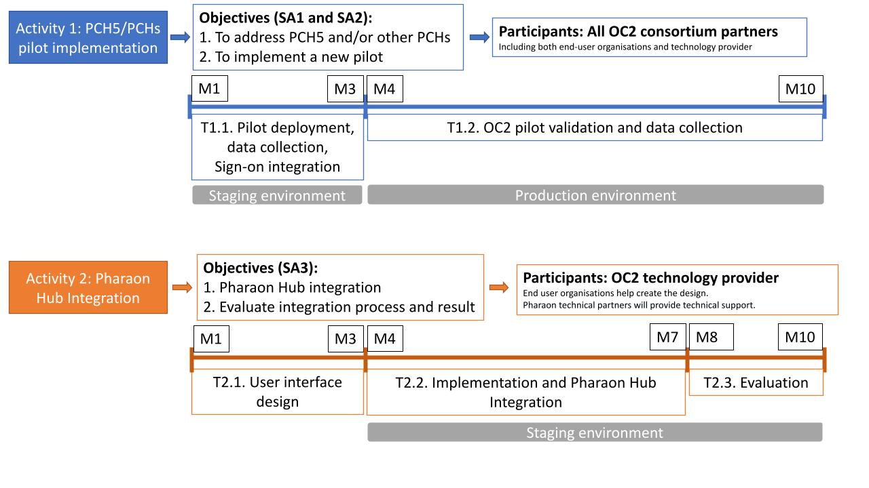
Figure 1. Planning of OC2 winner projects (in case of addressing all three SAs)

Applicant consortium size and available budget
The Second Pharaon Open Call will fund consortia of up to three partners, preferably with at least one SME, with mature, digital solutions that address one or more of the Pharaon Challenges. Each consortium will have to adapt its solution for integration with Pharaon ecosystem through the use of the Pharaon Hub and will have to carry out a small pilot that validates the solution and its Pharaon integration in real world scenarios.
The maximum budget earmarked for the financing of projects under this Open Call is EUR 2.500. 000,00 €. The maximum eligible sub-grant amount is 200.000,00 € per action. This open call is expected to fund up to 15 third party projects.
The estimated costs should be reasonable and necessary to implement the activities described in the work plan and follow the principles of sound financial management and efficiency.

Ethical considerations, data management, and quality control
All applicants must comply with the ethical standards of the Pharaon project, its data management, and quality control procedures.
Basic ethical principles of the project are outlined in the Guide for Applicants. All applicants are responsible for their own ethical clearances.
To ensure high quality, interim project reports that provide work plan updates and status reports will be required every 90 days from the start of the action. Reports should be short and precise, and include risk assessment and mitigation steps. Template is provided . Failure to comply or provide adequate evidence of progress may result in termination of the third-party project.
All participants must ensure that all hardware and software solutions comply with the GDPR. More details about data management will be provided to successful applicants during Grant Agreement preparation.

Eligibility criteria

General provisions (admissibility of submitted applications)
Applications must:
- Submit no later than the deadline for submitting applications referred to in Section 3;
- Submit using the online application form (link);
- Submit using the Pharaon Proposal template (link) without modification to its structure, i.e., keep all defined sections (even if not relevant for your proposal), and without changing the font, margins, line or text spacing, or other attributes meant to circumvent the page limit;
- Include all mandatory information indicated in the template;
- Within the scope of the Open Call, address at least one expected outcome;
- Written in English.
Failure to comply with these requirements will lead to the rejection of the application.

Applicant eligibility
In this Open Call, the same eligibility criteria with the H2020 rules of participation (Article 10) apply. Thus, every participant must be registered in a EU member state or in a Horizon 2020 associated country. More specifically, eligible to receive funding through this Open Call is any legal entity established in a Member State or associated country, or created under Union law. For more details refer to:
https://ec.europa.eu/research/participants/data/ref/h2020/grants_manual/hi/3cpart/h2020-hi-list-ac_en.pdf
This Open Call focuses on attracting small consortia consisting of up to 3 partners from the following categories:
- SMEs, and Micro SMEs as defined in the EU: EU recommendation 2003/361, including the UK
- Web entrepreneurs and individual sole-traders;
- Industrial organisations.
- User representative organisations (i.e., social organisations, retirement homes)
- Universities or Research Organisations
- Other eligible organisations with high TRL level activities.
Each partner of the consortia must have a validated Participant Identification Code (PIC) number.
Consortia other sizes may be considered. Including at least one SME or Micro SME is recommended.
Tentatively, one beneficiary could submit a maximum of 2 proposals, and only one proposal as coordinator.
Beneficiaries obtaining the cascade grant through the Pharaon Open Call 1 cannot submit the proposal to this call.

The consortium must:
- appoint a leading partner, the coordinator;
- grant the authorization to the coordinator and it’s responsible person for the signing of the cascade grant agreement and for communication with the contracting authority,
- define the scope of work to be performed by each consortium partner, including the financial distribution among the consortium partners,
- provide a statement indicating unlimited joint and several liability of all consortium partners towards the contracting authority.
In compliance with H2020 Annotated Model Grant Agreement regulations:
- Applicants must be previously registered in the Participant Register of the Participant Portal and have a VALIDATED 9-digit Participant Identification Code (PIC). Beneficiaries without validated PICs on the deadline for submitting the proposal will be disqualified. Proof of validated PICs must be attached to the submitted application.
- Applicants cannot request any funding for activities that are already funded by other grants (principle of no double funding). Furthermore, proposals from Linked SMEs must demonstrate that there is no risk of double funding.
- To avoid conflicts of interest, applications will not be accepted from persons or organisations who are partners in the Pharaon consortium or who are formally linked in any way to partners of the consortium. All applicants will be required to declare that they know of no such potential conflicts of interest that should prevent them from applying.
- Each applicant is limited to two submission per Open Call, and only one proposal as coordinator. If more than two submissions will be received from the same applicant, they will be disqualified (if multiple submissions are made, only the submission with the latest submission date will be considered).

Eligible activities
Development and Innovation activities that accelerate or expand the implementation of new or existing technologies on the Pharaon platform, bring new users while addressing PCHs (especially PCH5), or expand ecosystem capabilities are eligible for funding. These activities include, but are not limited to: software development, firmware development, hardware development necessary to integrate software or hardware solutions in the Pharaon ecosystem, user facing work such as recruitment, training, data collection and other related interactions, scientific work such as experimental design, analysis, and reporting, legal and ethical compliance activities, promotional activities related to the project, or similarly related activities. The TRL levels for these activities/solutions should be TRL 8 or 9, i.e., modification of existing solutions, or final stages of market readiness for new solutions.

Exclusion criteria
Applicants will be excluded from participating in the call for proposals procedure and from the cascade grant award if they are in any of the exclusion situations referred to in article 136(1) of the EU Financial Regulation 38, i.e., one of the following situations:
- The applicant is bankrupt, subject to insolvency or winding-up procedures, its assets are being administered by a liquidator or by a court, it is in an arrangement with creditors, its business activities are suspended, or it is in any analogous situation arising from a similar procedure provided for under EU or national laws or regulations;
- It has been established by a final judgment or a final administrative decision that the applicant is in breach of its obligations relating to the payment of taxes or social security contributions in accordance with the applicable law;
- It has been established by a final judgment or a final administrative decision that the applicant is guilty of grave professional misconduct by having violated applicable laws or regulations or ethical standards of the profession to which the applicant belongs, or by having engaged in any wrongful intent or gross negligence, including, in particular, any of the following:
  - Fraudulently or negligently misrepresenting information required for the verification of the absence of grounds for exclusion or the fulfilment of eligibility or selection criteria or in the performance of a contract, a grant agreement, or a grant decision.
  - Violating intellectual property rights.
Applicants must clearly declare they are not in one of the above mentioned situations by ticking all the relevant boxes in the Section 3 (Acceptance of the Pharaon Open Call Terms & Conditions) of the online Application form (link).

Application process

Open Call Procedures for Submission, Evaluation, and Grant Management
The procedures for the call are outlined in this document and detailed in additional documents found on the Pharaon website:
- Guide for applicants (link)
- Pharaon Proposal template (link)
- Model Cascade Grant Agreement (link)
Submissions will be handled through the Evalato platform. You may find the application form there. For further information about the submission process please consult Appendix 1 Application Submission Guide at the end of this document.
All successful applicants will be required to sign a Cascade Grant Agreement with the InnoRenew CoE, Izola, Slovenia, who is the cascade funding manager in the Pharaon Project.

Timetable
The approximate timetable for this Open Call is detailed in the table below.
Table 2 Approximate Open Call timeline
 | Stages | Date and time or indicative period
a) | Publication of the call | 31.07.2023
b) | Deadline for submitting applications | 30.09.2023, 17:00 CET
c) | Info sessions for potential applicants (webinar) | 08. 08. 2023
d) | Evaluation period | 30.09.2023 – 15.10.2023
e) | Information to applicants | 16.10.2023
f) | Signature of Sub-grant agreement | 17.10.2023 – 27.10.2023
g) | Starting date of the action | 01.11.2023

Evaluation process
The evaluation will be performed by a panel of external experts selected by the OCSC according to their specific knowledge of AAL, Industry, Health and Care, and Ageing. Budget allocation and final selection will be conducted by the Pharaon Open Call Steering Committee. Proposals are submitted in a single stage and evaluated as presented below.
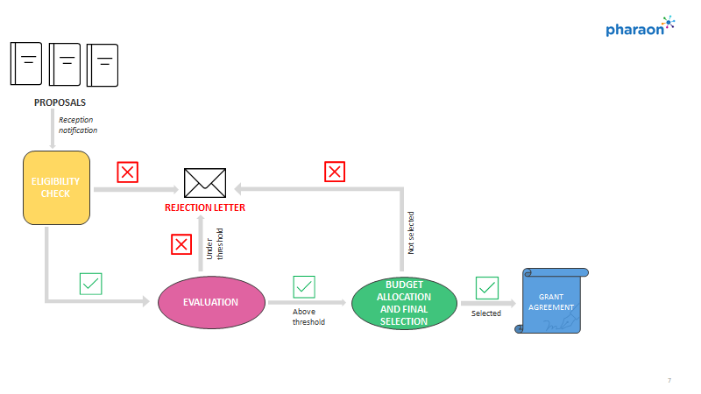
Figure 2. Pharaon Open Call evaluation process

For further details about the evaluation process please consult Section 3 of the Pharaon Guide for Applicants. To ensure all priorities are addressed in this call for proposals, we anticipate funding no more than two (2) applications per priority. In exceptional cases, more projects addressing a single priority gap may be funded when the quality is exceptional or in case some priority gaps are not addressed by a qualified application. If necessary, the Pharaon consortium may request clarifications from applicants. Requests for clarification are not indicative that an application will be selected.
Applicants who receive a score above the threshold will be invited for an interview conducting by the Pharaon project steering committee members. Interview of approximately 30 minutes with project coordinator performed remotely. The first part of the interview will be devoted to a presentation on the outline of the proposed project by the coordinator. The remaining time will be devoted to a question and answer session.

What’s next for selected proposals?

Agreement process
Applicants selected for funding will be asked to complete four documents:
- A bank identification document
- A declaration of honour
- A gaps tables which contains questions/concerns from reviewers and responses from the applicant
- A contract between the funding partner (InnoRenew CoE) and the beneficiary (applicant).
Forms or draft documents will be provided for each item. The signing process should take approximately 2 weeks if all documents are handled in a timely manner. A starting date is fixed and defined in chapter 5.2.

Technical evaluation
Both the work by the technical partner and the effectiveness of the Pharaon Hub will be evaluated.
We will evaluate integration progress and issues with the applicants and the Pharaon technology developers. An important part of the evaluation will be qualitative. Evaluation will involve approximately the following:
Quantitative evaluation:
- Development metrics, like # of open/resolved issues, # of sprint tasks, various other counts

Qualitative evaluation:
- Sprint-like biweekly meetings with task tracking.
- We want a way to elicit and record feedback from each applicant who uses each tool.
- Surveys
- Open interviews

Funding scheme

Administrate requirements of successful applicants
The Pharaon project has received funding from the European Union's Horizon 2020 research and innovation programme under Grant Agreement No 857188. Part of this agreement includes financial support to Third parties, via cascade funding which is available through this Open Call and any later open calls organised by the consortium. Hence, the selected Third parties are indirect beneficiaries of European Commission funding and as such must comply with the rules presented in the H2020 Annotated Model Grant Agreement in the same way as the direct beneficiaries of the Pharaon project. Contracts with them will be done by InnoRenew CoE, Izola, Slovenia (cascade funding partner).
Any legal binding commitment from the side of InnoRenew CoE shall be subject to the entering into written contractual agreement between InnoRenew CoE and the selected Third parties.
Selected Third parties must comply with all reporting requirements, which are described in section 6 of the Pharaon Guide for applicants.

Funding scheme and rules
The total financial support awarded by the cascade funding partner which, in this case, is InnoRenew CoE may amount to up to 100% of the eligible costs of the Third party project. According to the Article 5.2 (Chapter 3 Grant) of the H2020 Annotated Model Grant Agreement the grant reimburses 100% of the eligible costs for beneficiaries that are non-profit legal entities and 70% of the eligible costs for beneficiaries that are profit legal entities.
The Third party will be obliged to return all necessary justifications (deliverables, reports, and financial documents) to the cascade funding partner in order to allow the cascade funding partner to pay the Third party. The cascade funding partner will only pay according to the execution of the Cascade Grant Agreement.
In compliance with Article 15 (Chapter 4 Rights and obligations of the parties) of the H2020 Annotated Model Grant Agreement the Third party has obligation to comply with the following obligations:
- The beneficiaries must take all measures to prevent any situation where the impartial and objective implementation of the action is compromised for reasons involving economic interest, political or national affinity, family or emotional ties or any other shared interest (‘conflict of interests’).
- During implementation of the action and for five years after the end of the project, the parties must keep confidential any data, documents, or other material (in any form) that is identified as confidential at the time it is disclosed (‘confidential information’).
- The beneficiaries must promote the action and its results, by providing targeted information to multiple audiences (including the media and the public) in a strategic and effective manner.
- Except in case of force majeure, the beneficiaries must compensate the cascade funding partner for any damage it sustains because of the implementation of the action or because the action was not implemented in full compliance with the Cascade Grant Agreement.
The Third party will enable the cascade funding partner, the Commission, the European Court of Auditors (ECA) and the European Anti-Fraud Office (OLAF) to carry out checks, reviews, audits, and investigations of the activities funded under this Open Call.
If an audit of the Commission states that the direct costs of providing financial support to Third parties must be cancelled for reasons caused by a Third party, the cascade funding partner (InnoRenew CoE) will have the right to ask the Third party for the reimbursement of the corresponding costs.

Payments
The following payments will be made to the beneficiaries:
- one pre-financing payment: After signing of the Cascade Grant Agreement, a pre-financing payment of 50% of the eligible amount will be released.
- one final payment, based on the request for payment of the balance: 50 % final payment after approval of the final report. Payment is subject to the approval of the final report, which will occur within 60 days of the third-party project end date. Approval of the final report does not imply recognition of compliance, authenticity, completeness, or correctness of its content.
Payments will be made to the coordinator.
Payments to the coordinator will discharge the Contractor from its payment obligation.
The coordinator must distribute the payments between the partners without unjustified delay.

Eligibility of Costs
To be eligible all costs must comply with the rules and the principles described in Chapter 3, Article 6 (Eligible and ineligible costs) of the H2020 AGA – Annotated Model Grant Agreement.
Eligible costs consist of:
- Direct costs:
- direct personnel costs
  - costs for employees (or equivalent)
  - costs for natural persons working under a direct contract
  - costs of personnel seconded by a third party against payment
  - costs for SME owners without salary
  - costs for beneficiaries that are natural persons without salary
  - personnel costs for providing trans-national access to research infrastructure
- direct costs of subcontracting
- other direct costs
  - travel costs and related subsistence allowances
  - equipment costs
  - costs of other goods and services
  - capitalised and operating costs of large research infrastructure
  - costs of internally invoiced goods and services
- Indirect costs:
- indirect costs (25 % flat rate)
Accounting documentation is necessary only for direct costs. Indirect costs do not need supporting evidence because they are declared using a flat rate. If other direct costs exceed 15% of the total request grant amount, these costs must be justified in detail in the application. All subcontracting costs must be justified in detail in the application and should not cover an integral part of the proposed project.

Intellectual property rights
The ownership of all Intellectual Property Rights created by the beneficiaries via the Pharaon funding will remain with them. Results are owned by the Party that generates them. The Cascade Grant Agreement will introduce provisions concerning joint ownership of the results of the sub-granted projects. This will be assessed and negotiated case by case. Please refer to the Guide for applicants Chapter 5 and the Cascade Grant Agreement draft for more details.

Support for applicants
For more information about the Pharaon Open Call, please check the Frequently Asked Questions (FAQs) section included at https://www.pharaon.eu/open-calls.
For further information on the Open Call, in case of any doubt regarding the eligibility rules, the information that is to be provided in the Application Form, or if you encountered technical issues or problems with the submission of the Application Form, please contact Pharaon Technical Helpdesk email: opencall@pharaon.eu.
Dedicated information webinars will be organised, and recordings will be available on https://www.pharaon.eu/open-calls.

Right to Reject Proposals
Before the proposal due date and time listed in the timeline of the call, the InnoRenew CoE may cancel the call for any or no reason. After the proposal due date and time listed in the timeline of the call, the InnoRenew CoE may reject all proposals and cancel the call if the InnoRenew CoE determines that: (i) the proposals received do not reflect effective competition; (ii) the cost is not reasonable; (iii) the cost exceeds the amount expected; or (iv) awarding the contract is not in the best interest of the Pharaon project due to the contractual agreements with the European Commission. The InnoRenew CoE may or may not waive an immaterial deviation or defect in a proposal. The InnoRenew CoE’s waiver of an immaterial deviation or defect shall in no way modify the call or excuse a Proposer from full compliance with call specifications. Until a contract resulting from this call is signed, the InnoRenew CoE reserves the right to accept or reject any or all of the items in the proposal, to award the contract in whole or in part and/or negotiate any or all items with individual Proposers if it is deemed in the Pharaon project’s best interest. A notice of intent to award does not constitute a contract and confers no right of contract on any Proposer. The InnoRenew CoE reserves the right to issue similar calls in the future. The call is in no way an agreement, obligation, or contract and in no way is the InnoRenew CoE or the Pharaon project consortium members responsible for the cost of preparing the proposal.

Appendix 1 Application Submission Guide
- Go to the link Evalato - Pharaon Open Call: (link)
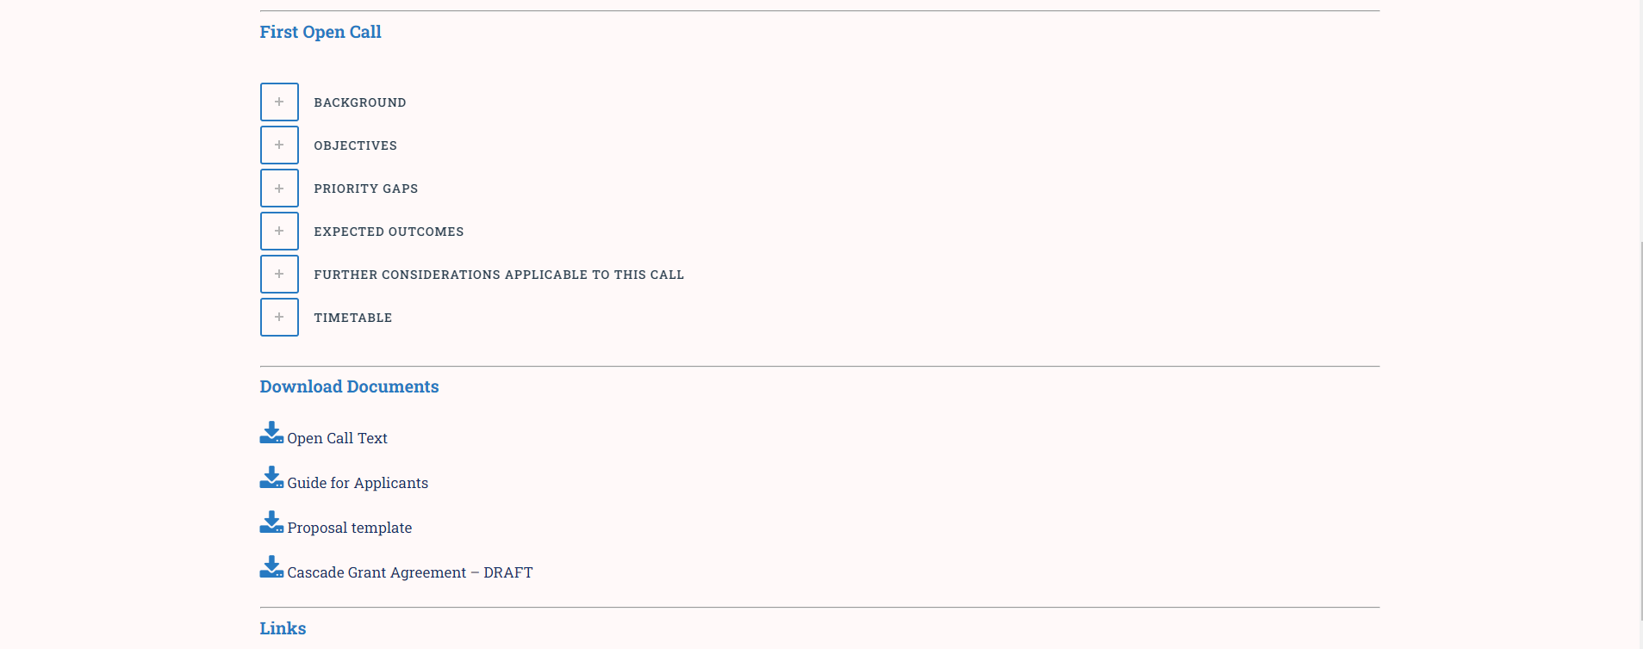
- Please enter your first name, last name, and email to register. 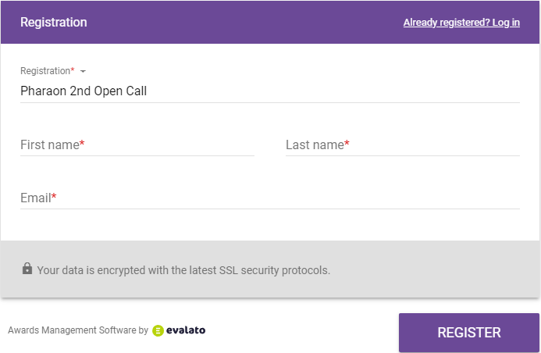
Upon successful registration you will receive confirmation email “Successful registration for Pharaon Open Call” with access link and PIN for your registration.
- Once registered you can start filling in the on-line part of the Application form, which can be saved as draft to continue work later or submitted once final. Please note that after submission no changes are possible. The following pictures present content of the on-line Application form. Fields marked with red are mandatory.
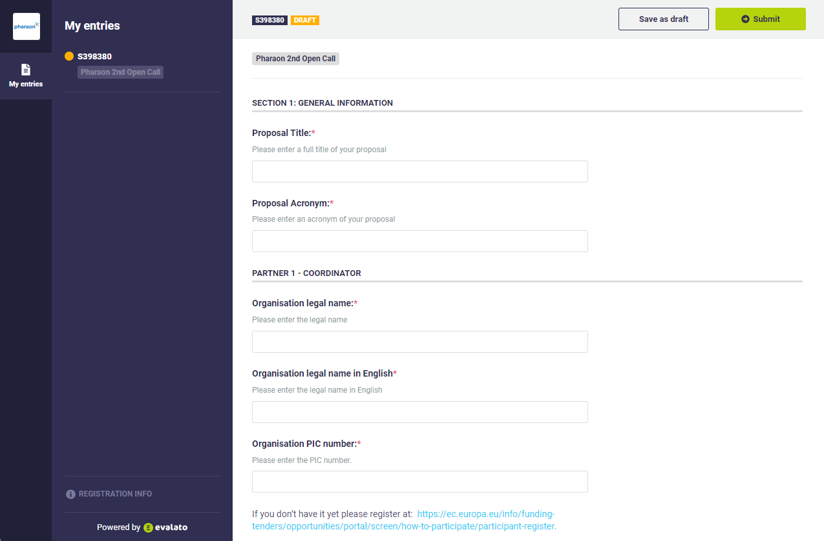
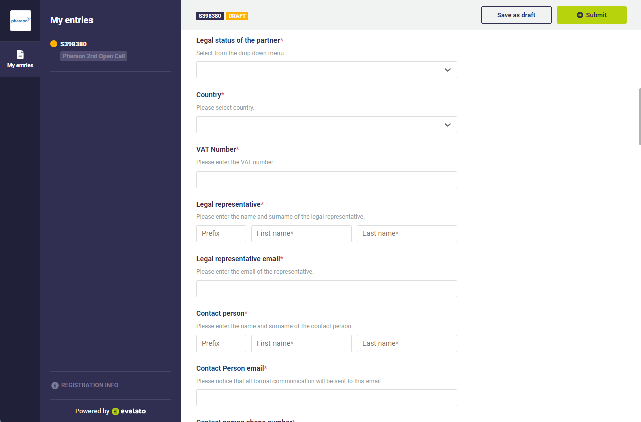

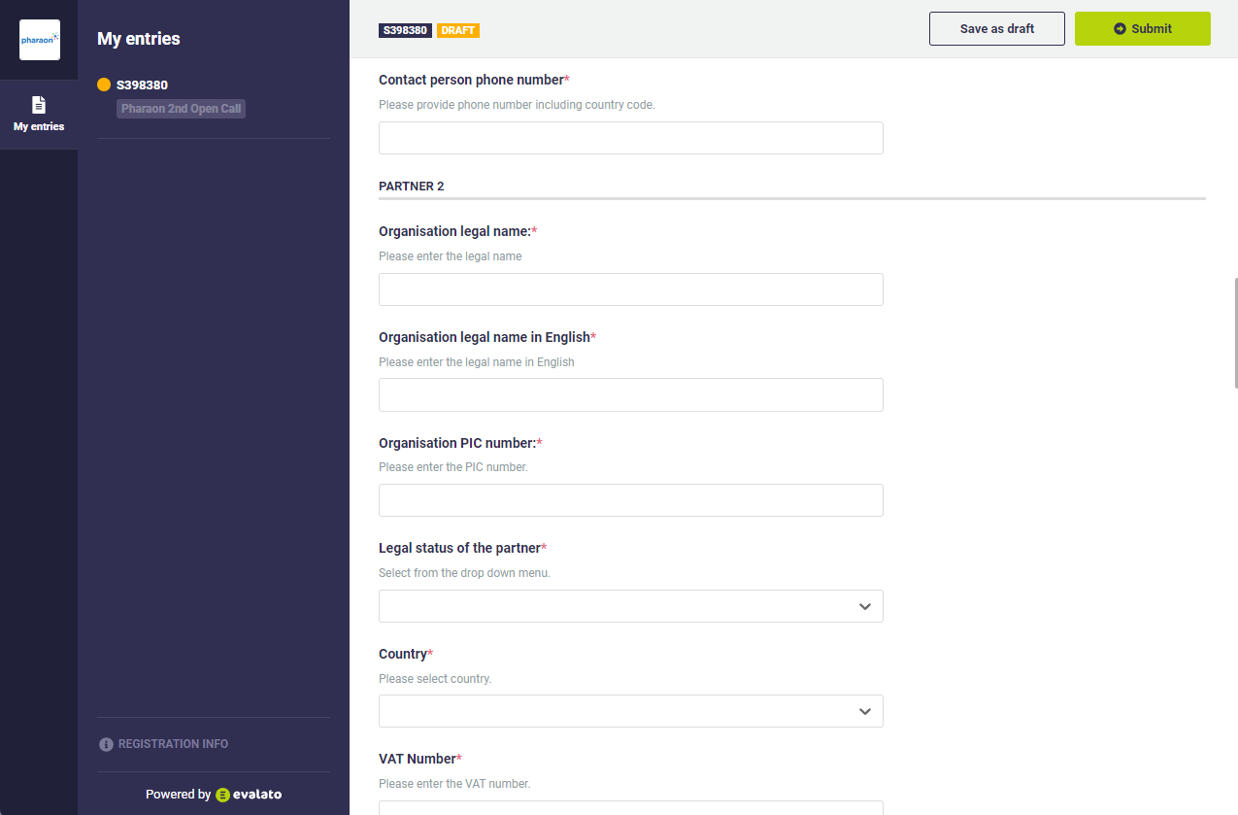
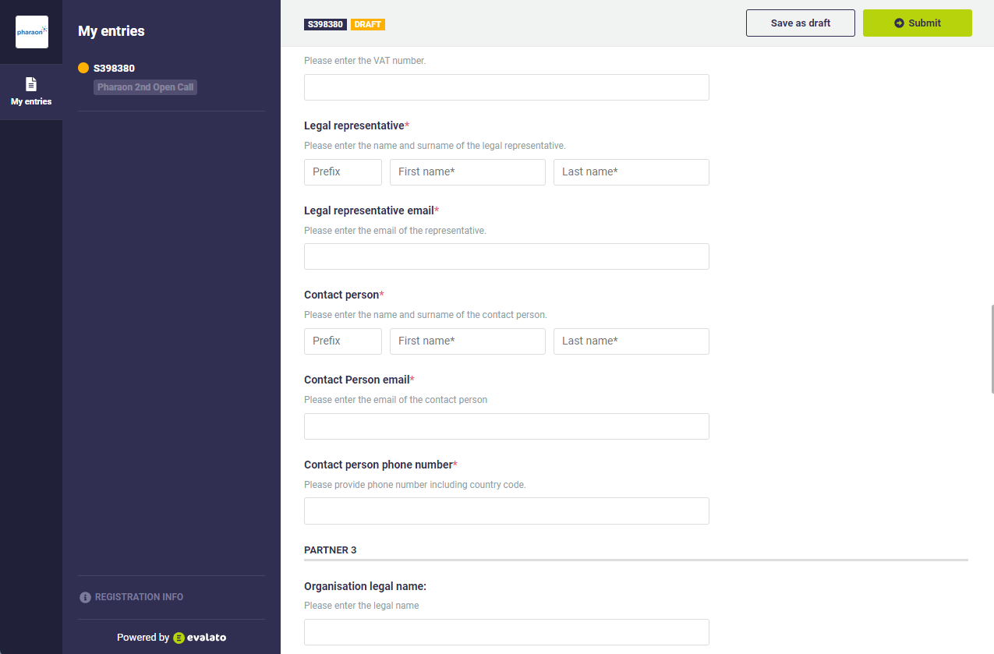

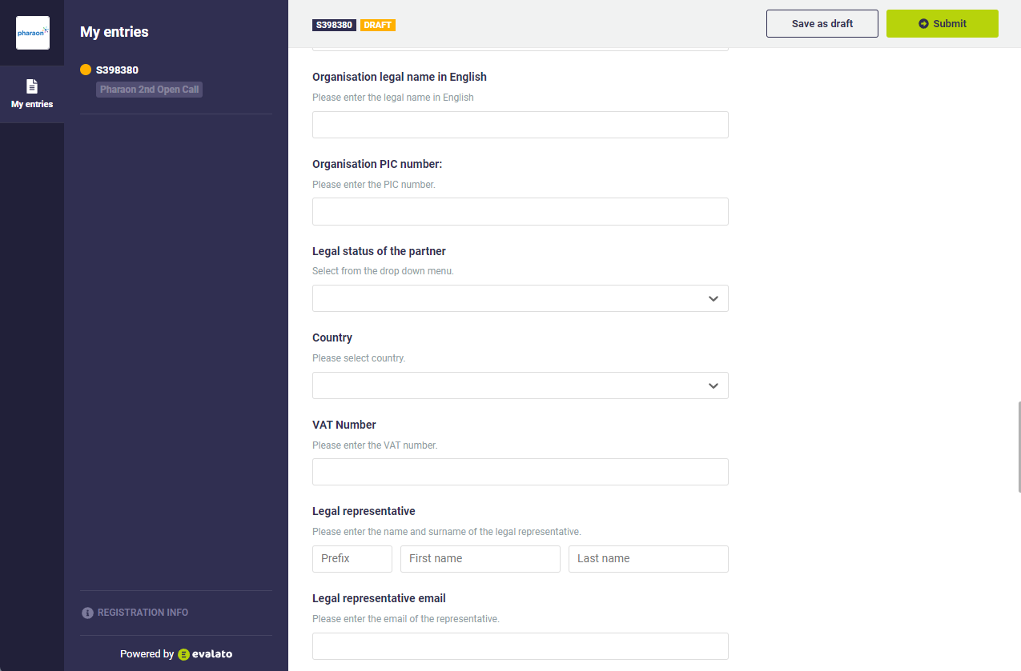
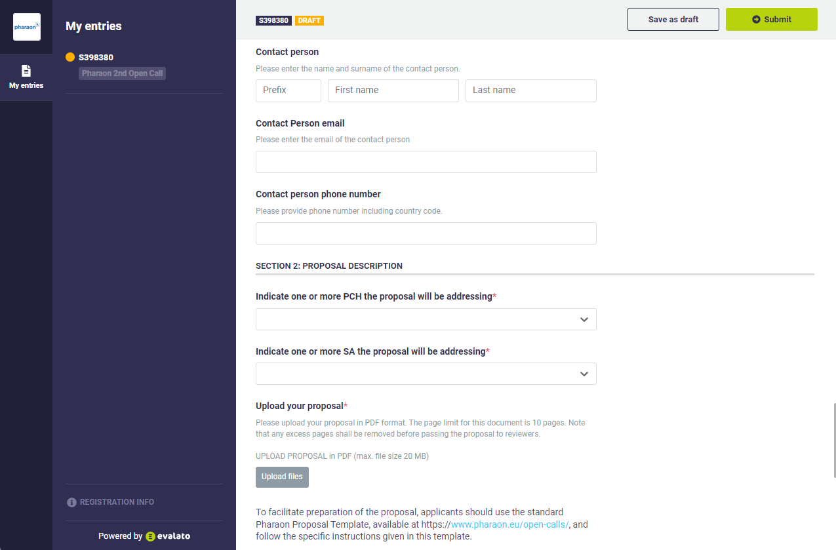
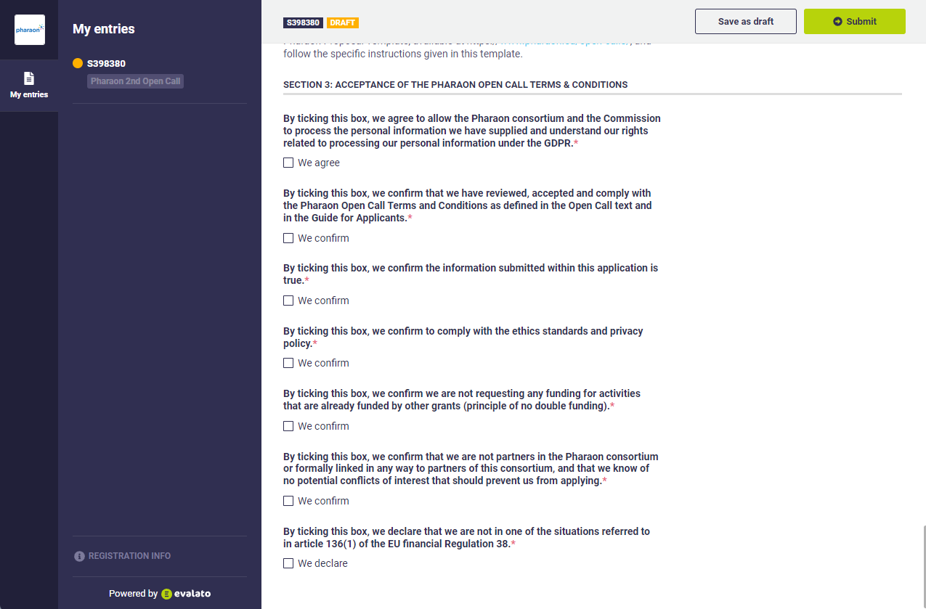

- After submission you will receive notification “Successful submission”.
In case of any trouble please contact us at opencall@pharaon.eu.

Acknowledgement: This project has received funding from the European Union’s Horizon 2020 Research and Innovation Programme under Grant Agreement No 857188. | Disclaimer: The content of this publication is the sole responsibility of the authors, and in no way represents the view of the European Commission or its services.

The PHArA-ON ecosystem can be considered as an e-health software ecosystem that integrates different technological platforms, each supporting a number of software applications and/or services.

