

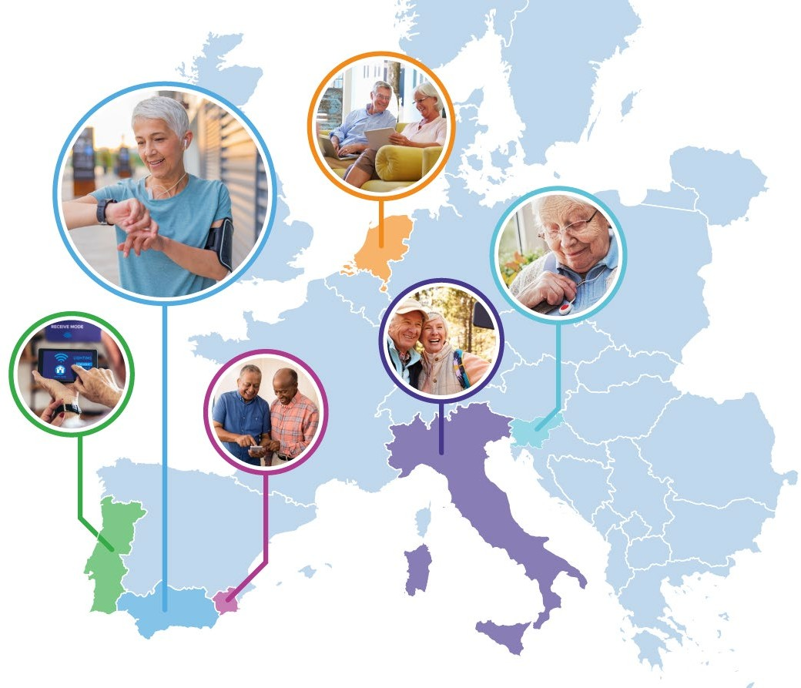


PILOTS FOR HEALTHY AND ACTIVE AGEING
Grant Agreement: 857188

Annex 2. Reporting procedures



This project has received funding from the European Union’s Horizon 2020 Research and Innovation Programme under Grant Agreement No 857188.

Annex 2. Reporting procedures

The reporting includes 2 interim progress reports (at month 4 and month 8) and final report. Reports need to be prepared on the reporting template provided in Annex 3. Interim report 1 and interim report 2 need to be submitted in month 5 and month 9, while final report 60 days after the end of the sub-project.

Reports should rely on a textual description of the work completed during the period, along with images and/or videos. Code contributions can be referenced if they are verifiable (i.e., are present on the project gitlab). The reports should focus on progress towards the completion of objectives and milestones. Work should be reported according to the tasks described in the Work Plan of your project. Please note any KPIs that have been reached or progressed towards. Evidence should be available for any progress or work described.

The handling of ethics issues should be described in a separate section. Include any information relevant to ethics, compliance with the GDPR (i.e., data processing agreements joined), etc.

Your reports will be verified by 2 Cascade Project monitors assigned to your project and may be reviewed by other Pharaon project members.

Please mention any concerns to the contact provided in the Cascade Grant Agreement.

Continuous progress monitoring

A spreadsheet for your project will be available online (PHArA-ON Open Calls Reporting) to track the indicators noted in the Measurement section below. This should be updated as often as manageable, but must be updated at by day 60, day 120, and by the last day of the project. Failure to do so may jeopardize your project.

Assessment

The assigned project monitors will review your reports and flag the report using the following signs:

- Green: Project is on track, all deviations in time and content are minor and the success of the Cascade Project and the expected outcome are not jeopardized. This includes the technical and impact-related KPIs.
- Yellow: There are deviations (delays in technical work, or in delivery of essential equipment; unexpected technical barriers) or other problems (e.g., illness) which create a notable risk. The project needs to discuss the contingency measures with the moderator, but the recovery and final success remains possible.
- Red: The project has critical deviations or delays and it is uncertain whether the experiment can recover. These can be technical (e.g., a core component cannot be developed as planned due to unforeseen limitations, such as accuracy which could not been foreseen at the proposal stage), or other conditions (e.g., long-term illness of core staff, bankruptcy of the Cascade partner). Urgent action is required and the general management of the Open Call Steering Committee partners and Pharaon Core Board needs to be involved to find a suitable solution.

