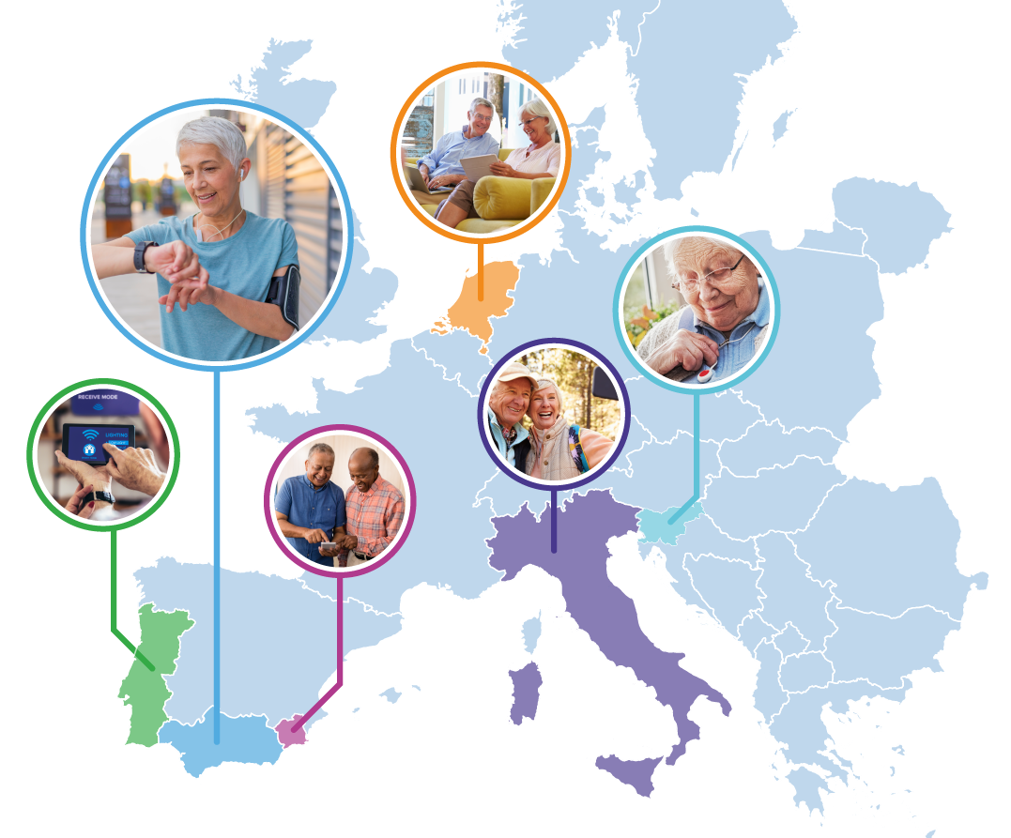

Pilots for Healthy and Active Ageing
Grant Agreement: 857188

Annex 3. The 1st, 2nd, Final report
Project title: _______________________________________________________________
Period covered by the report (dates): ___________________________________________
Periodic report [1st, 2nd, Final report]: ___________________________________________
Beneficiaries: ______________________________________________________________
Reviewers (two):____________________________________________________________

1. Explanation of the work carried out by the beneficiaries and Overview of the progress
- Explain the work carried out during the reporting period in line with the Cascade Grant Agreement.
- Include an overview of the project results towards the objective of the action in line with the structure given in the Cascade Grant Agreement including summary of deliverables and milestones, and a summary of exploitable results and an explanation about how they can/will be exploited.
- (Max 4 pages).

1.1 Objectives and milestones
- List the specific objectives and milestones for the project as described in the Cascade Grant Agreement and described the work carried out during the reporting period towards the achievement of each listed objective. Provide clear and measurable details. Additionally complete bellow tables (Table 1 and Table 2). Note to which degree they were achieved and if there were any deviations from the plan.

Table 1: Project objectives and level of their achievement.
Project Objectives | Level of achievement  (fully achieved, partially achieved, not achieved) | Deviations

Table 2: Project milestones and level of their achievement.
Project Milestones | Level of achievement  (fully achieved, partially achieved, not achieved) | Deviations

1.2 Work carried out during the project
- Please provide a short description of the work carried out in the project. Please relate your descriptions to tasks as described in your work plan. (Max 3 pages).
- The work carried out by each beneficiary should be described and efforts of each beneficiary per work packages given in Table 3. The efforts should be calculated following the instructions that 1 PM equals 144 hours.

Table 3: Participation per beneficiary per work package effort in person months (PM)
 | WP1 | WP2 | WP3 | WP4 | WP5 | WP6* | Total
P1
P2
P3
(add rows if needed)
Total
*Add columns if needed

2. Dissemination and exploitation activities
- Please provide a description of any dissemination activities carried out in the frame of the project. When available, provide links or screenshots. Copies of fliers or other outputs should be sent with this document as a means of additional verification. (Max 1.5 pages).

3. Use of resources
- Include explanations on deviations of the use of resources between actual and planned use of resources in Annex 1, especially related to person-months per work package.
- Fill in the data in Table 4, Table 5, and Table 6.

Table 4: Use of resources per beneficiary and work packages as occurred and as foreseen in Annex 1 of the Specific Grant Agreement.
 |  | WP1 | WP2 | WP3 | WP4 | WP5 | WP6* | Total
P1 | Actual
P1 | Annex 1
P2 | Actual
P2 | Annex 1
(Add rows if needed) | Actual
(Add rows if needed) | Annex 1
Total | Actual
Total | Annex 1
*Add columns if needed

Table 5: Explanation of the changes in use of resources per beneficiary.
Beneficiary | Change in use of resources
P1
P2
(Add rows if needed)

Table 6: Other direct costs foreseen in Annex 1 of the Grant Agreement and Actual other direct costs reported in financial report.
Beneficiary | Other direct costs foreseen in Annex 1 [EUR] | Actual Other direct costs reported in financial report [EUR] | Requested Pharaon contribution [EUR]
P1
P2
(Add rows if needed)

4. Ethical aspects
- Please provide a short over view of the steps taken to align with general best ethical practices, the Pharaon ethics guidelines, and the GDPR. (Max ½ page).

5. Conclusions & Other comments
- Please provide any other comments about your work relevant to the assessment of your project. (Max 1 page).

* Two documents to be submitted for each reporting periods:
- For the R1, R2 and final report: Report prepared in the way set out in this Annex (word)
- Continuous reporting: data, finance, milestones, KPIs, dissemination (Annex 4 - excel file)
- Please attach supporting documents for eligible costs when the final report is submitted.

The two Reviewers hereby confirm the report is (see Annex 2.):
Green
Yellow
Red

Reviewer 1  Name and Surname  Signature  Done at _______________ on ______________ | Reviewer 2  Name and Surname  Signature  Done at __________ on_________________ | Contractor InnoRenew CoE  Name and Surname  Signature  Done at __________ on_________________

