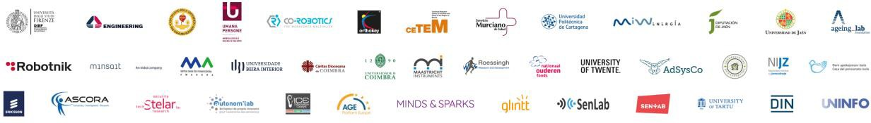

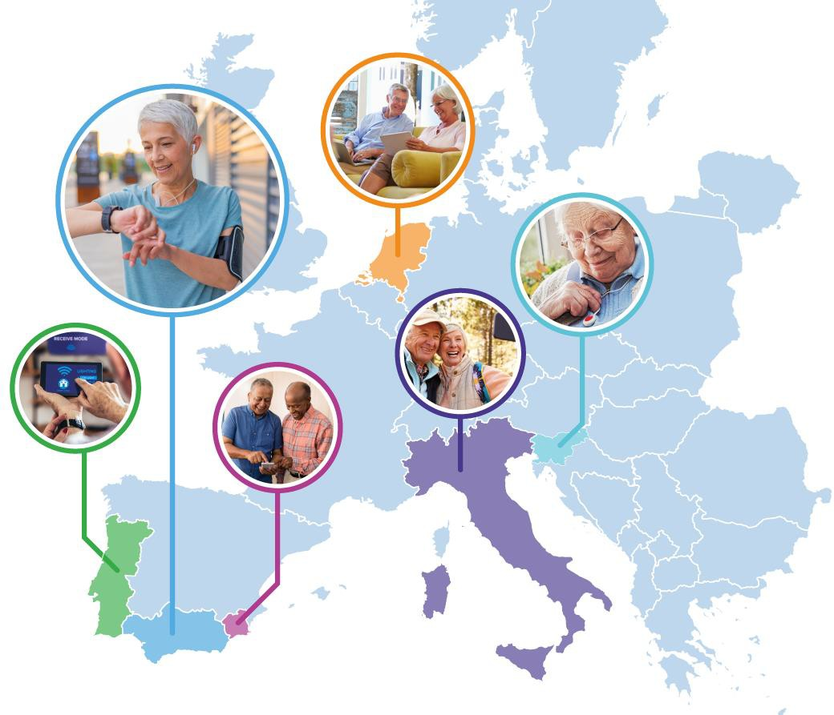


PILOTS FOR HEALTHY AND ACTIVE AGEING
Grant Agreement: 857188

Guide for Applicants


This project has received funding from the European Union’s Horizon 2020 Research and Innovation Programme under Grant Agreement No 857188.

Contents

1 Introduction 5
1.1 About Pharaon 5
The Pharaon consortium brings together the following members: 5
2 Submission of proposals 6
2.1 Key documents 6
2.2 Language of the proposal 6
2.3 Online Application form 6
2.4 Pharaon Proposal template 6
2.5 Submission completion 6
2.6 Additional information 8
3 Evaluation and next steps 8
3.1 Admissibility and Eligibility check 8
3.2 Evaluation process 9
3.3 Final evaluation results 10
3.4 Operational capacity 10
3.5 Award criteria 10
3.6 Cascade Grant Agreement signature 12
4 Ethics guidelines and privacy policy 12
4.1 Ethics guidelines 12
4.2 Privacy policy 1
5 Intellectual property rights (IPR) 2
5.1 IPR ownership of the sub-granted projects 2
6 Managing your grant 2
6.1 Keeping records and other supporting documentation 3
6.2 Report and payment request 3
6.3 Communication obligations 3

Acknowledgement: This project has received funding from the European Union’s Horizon 2020 Research and Innovation Programme under Grant Agreement No 857188. | Disclaimer: The content of this publication is the sole responsibility of the authors, and in no way represents the view of the European Commission or its services.

Figures
Figure 1. Admissibility and eligibility check process 6
Figure 2. Evaluation process 7
Figure 3. Process after evaluation is finalized 8
Acronyms & Abbreviations

Term | Description
GDPR | General Data Protection Regulation
CR | Consensus Report
FAQ | Frequently Asked Question
IER | Individual Evaluation Report
OCSC | Open Call Steering Committee

Introduction
This Guide is designed to assist you in preparing and submitting the proposal and answer questions you may have in this process. It is based on the rules and conditions of the Horizon 2020 programme presented in the Annotated Model Grant Agreement. The Guide does not in itself have legal value and does not supersede this document.
In case of further questions, the following options are also available:
- Frequently Asked Question (FAQ) section on the Pharaon web page: https://www.pharaon.eu/open-calls (link)
- The Pharaon help desk is available via email: opencall@pharaon.eu. The help desk is unavailable on weekends and public holidays.
Please note:
Every selected applicant will be required to sign a Cascade Grant Agreement, a model example of which can be found at the Pharaon website (link).

About Pharaon
The overall objective of the Pharaon project is to provide support for Europe’s ageing population by integrating digital services, devices, and tools into the open Pharaon platform that can be readily deployed while maintaining the dignity of older adults and enhancing their independence, safety, and capabilities. The project utilises a range of digital tools including connected devices (e.g., the Internet of Things, IoT), artificial intelligence, robotics, cloud and edge computing, smart wearables, big data, and intelligent analytics that will be integrated to provide personalised and optimised health care delivery.
During the implementation of the project some gaps have been identified between the technological needs of the pilot sites and the solutions that are available in the Pharaon partnership. The purpose of this open call is therefore to involve new stakeholders and their technologies, products, or services in the Pharaon ecosystem.

The Pharaon consortium brings together the following members:
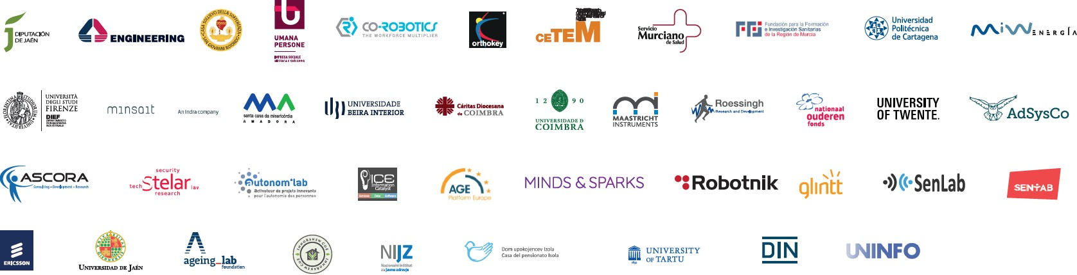

Submission of proposals

Key documents
Prior to submitting a proposal and filling in the online Application form, please verify whether your organisation, product or service comply with the eligibility criteria. You should also check whether your technologies or services are in line with the ones listed in the Open Call. For this reason, the very first step is to go through the relevant documentation in detail, namely:
    - The Pharaon Open Call (link)
    - The Pharaon Open Call Technical Information (____)
    - The Frequently Asked Questions (FAQ) on the Open Call and submission of proposals (link)
      - The Cascade Grant Agreement for the Pharaon Open Call and
Annex 2, 3, 4 (link)
      - All documents are available at https://www.pharaon.eu/open-calls/(link).

Language of the proposal
Proposals must be submitted in English. In addition, applicants should be aware that the Pharaon Consortium will, in principle, use English to communicate with beneficiaries regarding the follow-up and the monitoring of the co-financed solutions (grant management stage).

Online Application form
Online Application form comprises fields of required information, checklists and declarations to be filled and must be completed directly via the online submission tool. For further information please consult Appendix 1 Application Submission Guide of the Pharaon Open Call document (link).

Pharaon Proposal template
Pharaon Proposal template concerns the technical content of the proposal. To facilitate its preparation, applicants should use the standard template provided on this link and follow the specific instructions given in this template. The page limit for this document is 10 pages. Note that any excess pages shall be removed before passing the proposal to reviewers.
It is important to fill in all predefined sections and to address questions mentioned in the presented document; they are meant to guide the applicants in the preparation of a proposal and cover all important aspects of a proposal. This will enable the independent experts to make an effective assessment against the award criteria. You can write your proposal in any word processing tool. However, once completed, please save it as a PDF file and upload to the online submission tool only PDF file.

Submission completion
Proposals for the Pharaon Open Call are submitted in a single stage via online submission tool. Proposals submitted by any other means, will not be evaluated. The deadline for submission is indicated in the Pharaon Open Call. After the deadline for the submission of the proposals, changes or additions are no longer possible. The date and time of the submission of the application will be automatically recorded and an acknowledgement of receipt will be sent to the applicant by email.

Additional information
Please note that applicants are solely responsible for the content and nature of their submission to the Pharaon Open Call. They are also obliged to ensure that no legal obligations are violated and that they act according to the laws of their country.
The Pharaon consortium shall not be liable in the event of loss of submitted proposal namely due to the network interruptions. In case of any problems with the submission system, applicants will have to send timely notification via the email (opencall@pharaon.eu).

Evaluation and next steps
All proposals received go through a multi-level process of evaluation with regards to several categories of criteria announced in the Open Call. The assessment of each proposal will be based exclusively on the information provided by the applicants in the proposal submitted and the experts will be instructed to ignore any hyperlinks to external information.
The evaluation of proposals is carried out in the strictest confidence. Under no circumstance may an expert attempt to contact an applicant directly, either during the evaluation or afterwards.

Admissibility and Eligibility check
Submitted proposals will be checked for inadmissibility and ineligibility (against the eligibility criteria set out in the Pharaon Open Call).
If your proposal is considered inadmissible or ineligible, we will inform you via email, together with the reasons why. Such proposals will not enter the evaluation phase.
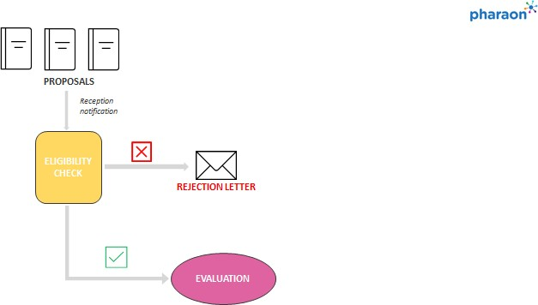
Figure 1. Admissibility and eligibility check process

Evaluation process
Each proposal will be evaluated by two experts who are independent, impartial, objective, consistent and where no conflicts of interest exist.
All evaluations are carried out in the light of the same basic principles:
    - Excellence: the proposals selected for funding must demonstrate a high quality in the context of the topics and criteria set out in the Open Call.
    - Transparency: funding decisions are based on clearly described rules and procedures, and all applicants will receive adequate feedback on the outcome of the evaluation of their proposals.
    - Independence: evaluators assess proposals on a personal basis. Evaluators represent neither their employer nor their country.
    - Impartiality: all proposals submitted to the Open Call are treated equally. They are evaluated impartially on their merits, irrespective of their origin or the identity of the applicants.
    - Objectivity: evaluators assess each proposal as submitted not on its potential if certain changes were to be made.
    - Accuracy: evaluators make their judgment against the official evaluation criteria of the Open Call the proposal addresses, and nothing else.
    - Consistency: evaluators apply the same standard of judgment to all proposals.
    - Confidentiality: all proposals and related data, knowledge and documents are treated in confidence.
The evaluation process has three phases:
    - Phase 1 — Individual evaluation: Each expert carries out an evaluation and prepares an
‘individual evaluation report’ (IER) with comments and scores for each criterion.
    - Phase 2 — Consensus report: Two experts reach consensus and agree on comments and scores in a ‘consensus report’(CR). If during the consensus discussion it is found to be impossible to bring the two evaluators to a common point of view on any particular aspect of the proposal, additional evaluator may be invited to review the proposal.
    - Phase 3 — Panel review: After the consensus phase a panel of experts reach an agreement on the scores and comments for all proposals within a call, checking consistency across the evaluations. If necessary and duly justified, propose a new set of marks or revise comments, and resolve cases where evaluators were unable to agree. The panel will comprise experts writing consensus reports.
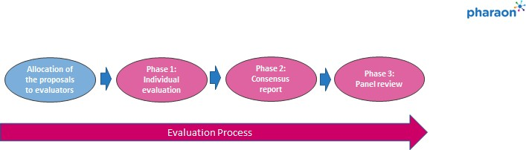
Figure 2. Evaluation process

Final evaluation results
Open Call Steering Committee (OCSC) will closely follow the Open Call evaluation process and approve the final list of co-funded proposals following the below presented procedure:
    - OCSC ranks the proposals having a qualifying score and gives a priority order for proposals with the same score using the procedure set out in the chapter 3.5 Award criteria.
    - Based on the available budget draws up a list of proposals for possible funding.
    - Decide on a reserve list of proposals that may be offered funding if a higher-scoring project does not go ahead or additional funds become available.
Once the evaluation has been finalised, all applicants – successful or not – will be notified of the results by email.
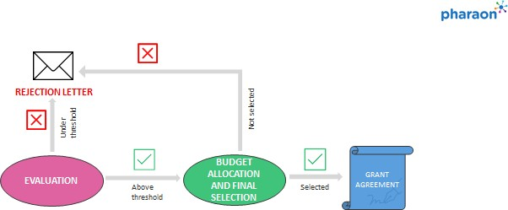
Figure 3. Process after evaluation is finalized

Operational capacity
During the evaluation of the award criterion “Quality and efficiency of the implementation” experts will indicate whether the participant has, or will have in a due time, a sufficient operational capacity to successfully accomplish foreseen tasks in the proposed work plan. This assessment will be based on the competence and experience of the applicant, including its operational resources (human, technical and other) and, if applicable, exceptionally the concrete measures proposed to obtain it by the time of the implementation of the tasks.

Award criteria
Following the evaluation, all eligible proposals are ranked according to the total number of points attributed in the evaluation of the award criteria. Only proposals meeting all thresholds are eligible for co-funding. The highest ranked proposals will be awarded co-financing depending on the budget availability. If all eligible proposals fall below the thresholds no selections will be made and open call might be reopened at a later date. The independent experts will be advised to perform the proposal evaluations, including their rating and ranking, in accordance with requirements and objectives specified in the Open Call, along with the following criteria:

Award criteria | Threshold | Max. score
Impact  Sub-criteria:  - The extent to which the outputs of the proposal would contribute to the expected impacts mentioned in the Pharaon Open Call.  - Contribution to any other substantial impact that would enhance innovation capacity and create new market opportunities. | 3 | 5
Innovation and technology (Excellence)  Sub-criteria:  - Clarity and pertinence of the objectives, compliance with the Pharaon challenges.  - Relationship between the proposed solution and pilot priority gap(s) addressed.  - Soundness of the concept, and credibility of the proposed methodology  - Extent that proposed work is ambitious, has innovation potential, and is beyond the state of the art (e.g. ground breaking objectives, novel concepts and approaches). | 4 | 5
Quality and efficiency of the implementation  Sub-criteria:  - Quality and effectiveness of the work plan, including extent to which the resources assigned to work packages are in line with their objectives and deliverables.  - Sufficient operational capacity to successfully carry out all tasks in the proposed work plan. | 3 | 5
TOTAL | 10 | 15

Minimum thresholds for the proposal to be eligible is 10. Proposals falling below the overall and/or the individual thresholds announced above shall be rejected.
Each criterion will be weighted on a scale from 0 to 5 (half point scores may be given), as follows:
    - 0 Very poor. The proposal fails to address the criterion or cannot be assessed due to missing or incomplete information.
    - 1 Poor: The criterion is inadequately addressed, or there are serious inherent weaknesses.
    - 2 Fair: The proposal broadly addresses the criterion, but there are significant weaknesses.
    - 3 Good: The proposal addresses the criterion well, but a number of shortcomings are present.
    - 4 Very good: The proposal addresses the criterion very well, but a small number of shortcomings are present.
    - 5 – Excellent: The proposal successfully addresses all relevant aspects of the criterion. Any shortcomings are minor.

When scores are equal, any further prioritization will be based on the following:
    - If there are two (or more) proposals with the same number of points, then the proposal(s) which fulfil the unmet needs of the Pharaon Pilot sites will be prioritised. It means that between two ex-aequo proposals, the Open Call Steering Committee (OCSC) shall select the proposal that contributes new solutions (as opposed to duplicated solutions) to a pilot site.
    - If this criterion cannot be applied, then the OCSC shall select the proposal which received the highest score for the individual award criteria. It will first compare the scores for ‘Innovation and technology’, then for ‘Impact’, and finally for ‘Quality and efficiency of the implementation’.

Cascade Grant Agreement signature
Successful applicants will be invited to sign the Cascade Grant Agreement in English (please see Draft Cascade Grant Agreement for more details).

Ethics guidelines and privacy policy

Ethics guidelines
All research activities and technological stakeholders in the Pharaon ecosystem should respect fundamental ethical principles, including those reflected in the Charter of Fundamental Rights of the European Union. Therefore, questions about ethical issues have to be addressed in the proposal. Globally, the core ethical principles that final beneficiaries will need to follow are mainly divided into two particular areas:
- Legal regulations and demands, not only related to General Data Protection Regulation (GDPR, better described under the next subsection - 4.2 Privacy policy), but also to the ethical compliance with European standards and legal procedures in each country or region.
- Measures to protect vulnerable individuals and groups, as research human subjects in the Pharaon study, both to ensure participants’ rights and freedoms (such as equity, accessibility, safety), and to minimize the main stigmatization risks (such as ageism, gender bias, digital gap).
Still, concretely, the following topics are worth applicants’ attention:
  - Ethics as a framework: Technical development is often siloed and distributed by different partners. It is thus crucial that they keep in mind the final purpose of their work, as a common ethical mindset.
  - Legal behaviour is not enough: Ethical compliance goes much beyond legal demands. Keeping older adults’ dignity and boosting their autonomy, safety and capabilities involves focusing on ethical effects.
  - Human lives behind tech: Technological solutions in Pharaon will highly influence participants’ lives. Ethical duties for tech partners thus include having a deep knowledge of the different pilot scenarios.
  - Other IT related risks: Ethical issues involving technology rely on a dynamic pathway. Extensive testing of new products before release is needed to realize how software, hardware, and data will be used.

  - Avoid insular knowledge: promoting communication among tech and non-tech partners, by aligning different languages and mindsets allows to implement basic risk prevention and mitigation actions.
  - Envision the ecosystem: as technological solutions in Pharaon are to be integrated, adapted and tested in different ecosystems, for larger uptake, the full context of the technology appliance in each setting (culture, expectations, values and priorities) must be considered.
  - Mind the gap on user expectations: Only if Pharaon solutions are duly explained to pilot partners, can then they duly explain them to users, also adjusting their initial expectations. Basic manuals for each solution, with lay language and simple concepts shall be made available by all tech partners in Pharaon.
  - Chain of ethical accountability: to ensure an effective ethical conduct tech partners shall clearly and detailly assign internal chains responsible for managing ethical risk and prevention of harm.
  - Crisis simulations: Besides the potential effects of a solution, within its predicted use case scenario, worst-case-scenarios and non-ideal conditions shall be foreseen to ensure an effective crisis response.
  - Privacy and security by design: from the start, either technical design (of networks, databases, devices, platforms, websites, tools, or apps), as social and organizational design (of groups, policies, incentives, procedures, resource allocations) in Pharaon shall be conceived to promote privacy and security goals.

Privacy policy
All data collected and/or processed within the Pharaon project will need to be compliant with GDPR and any applicable laws at national level. The following additional legal requirements should be addressed:

    - Regulation (EU) 2018/1807 of the European Parliament and of the Council of 14 November 2018 on a framework for the free flow of non-personal data in the European Union (especially Recital 9 and Article 2(2)),
    - EU ePrivacy Directive and
    - the security requirement of the EU Radio Equipment Directive.
In addition, standards on the following items should be taken into account:

    - Privacy management, see e.g. ISO/IEC 27701, ISO 27799,
    - Data protection and privacy by design, see e.g. prEN 17529 (public consultation draft), ISO/IEC 29134,
    - Pseudonymization and de-identification techniques, see e.g. ISO 25237, ISO/IEC 20889,
    - Secure health software development lifecycle, see e.g. ISO/IEC 62304.
Approaches to the following technical goals of personal data protection should be outlined:

    - Confidentiality: (privacy-relevant) data and services that process data cannot be accessed by unauthorized entities (security of communication, storage and possibly even processing).
    - Integrity: (privacy-relevant) data and services that process data cannot be modified in an unauthorized or undetected manner.

    - Availability: access to (privacy-relevant) data and to services that process data is always granted in a comprehensible, processable, timely manner.
    - Unlinkability: privacy-relevant data cannot be linked across domains that are constituted by a common purpose and context. This means achieving Data Minimization (again), Purpose Limitation and Binding and Undetectability.
    - Transparency: privacy-relevant data processing−including the legal, technical, and organizational setting−can be understood and reconstructed at any time. This could also be called Openness, Accountability, Documentation, Auditability, Full-Disclosure.
    - Intervenability: intervention is possible concerning all ongoing or planned privacy-relevant data processing. This includes Self-determination, Rectification or Erasure of Data, Consent Withdrawal and Process Interruption Process Interruption.

Intellectual property rights (IPR)

IPR ownership of the sub-granted projects
The ownership of all intellectual property created by the beneficiaries, via the Pharaon Open Call cascade funding, will remain with them. The Cascade Grant Agreement will define provisions regarding joint ownership of the results of the granted projects.
The background information owned and contributed by other partners remains subject to sharing agreements defined in the CSA of the Pharaon project.
No rights of ownership are transferred without previous signed agreement between any beneficiary of the Pharaon project.
The project intellectual property, e.g., the Pharaon platform is jointly owned by the beneficiaries defined in the original CSA. Beneficiaries of the open call are not granted ownership of any output covered in the original CSA.
Joining Parties shall not have Access Rights to Background or Foreground IPR of the other Pharaon Parties, including other joining Parties, except for situations when sharing background is necessary to reach project goals. Joining Parties remain the owner of all Background belonging to them and all Foreground arising from their cascade funding proposal. They shall not be obliged to grant Access Rights to such Background or Foreground to the other Parties, including to other Joining Parties. Granting of Access Rights shall be subjected to separate agreements between the concerned parties if needed (e.g. when sharing background is necessary to reach project goals).

Managing your grant
After signing the Cascade Grant Agreement beneficiaries will be included in consortium briefings and project partners will ensure that they are fully briefed on any developments within the project, including relevant meetings, events, and news.

Keeping records and other supporting documentation
The beneficiaries must keep records and other supporting documentation (originals) for a period of five years after the payment of the balance to prove the proper implementation of the action and the costs they declare as eligible. The evidence must be verifiable, auditable, and available. They must make them available upon request or in the context of checks, reviews, audits, or investigations. As explained in the article 18 (Chapter 4 Rights and obligations of the parties) of the H2020 Annotated Model Grant Agreement the beneficiaries must keep the records and documentation supporting the costs declared, in particular the following:
    - for actual costs: adequate records and other supporting documentation to prove the costs declared, such as contracts, subcontracts, invoices, and accounting records. In addition, the beneficiaries’ usual cost accounting practices and internal control procedures must enable direct reconciliation between the amounts declared, the amounts recorded in their accounts and the amounts stated in the supporting documentation;
    - for flat-rate costs: adequate records and other supporting documentation to prove the eligibility of the costs to which the flat-rate is applied. The beneficiaries do not need to identify the costs covered or provide supporting documentation (such as accounting statements) to prove the amount declared at a flat-rate.

Report and payment request
In addition to two interim project reports the beneficiaries will be requested to submit one report that contains a technical and financial report (“final report”) linked to the request for the payment of the balance. Further details are included in the Cascade Grant Agreement.

Communication obligations
In line with the Article 38 of the H2020 Annotated Grant agreement in any communication or publication the beneficiaries shall clearly indicate that the project has received funding from the European Union via the Pharaon project. This includes displaying the EU and project logo as well as the Pharaon grant number on all printed and digital material, including websites and press releases related to the project. For communication activities also the following text must be included:
“This project has received funding from the European Union’s Horizon 2020 research and innovation programme under project Pharaon (grant agreement No 857188), through the Pharaon open call instrument for financial support to third parties”. Furthermore, the beneficiaries are obliged:
    - To prepare information for the CATAALOG platform (utilised to provide an overview of AAL solutions), by describing the technology provided, its commercial information, its technical and functional aspects, its additional attributes (contact points, links, images) and its contribution to the identified gaps in the Pharaon Consortium. The provided information can be also used to create marketing materials used by the Pharaon consortium at public events or for other promotional purposes.
    - To prepare a PPT presentation describing the technology provided and its contribution to the identified gaps. This PPT presentation can be used either by beneficiary or partners of the Pharaon consortium to present results of the Open Call to EC representatives (e.g. at the Technical Review Meeting).

