Call for Evaluators

The PHARAON project (https://www.pharaon.eu/) is looking for external evaluators to support the review process of the proposals received form the second PHARAON Open Call (https://www.pharaon.eu/open-calls/).

Evaluator’s profile

Evaluators should have expertise in the following areas: Ambient Assisted Living (AAL), Health and Care, and Active and Healthy Ageing.

Experts with experience in reviewing H2020 grant applications are preferred.

Why becoming a Pharaon evaluator?

- You get reimbursed for your evaluation work
- You get to play a role in the selection of the solutions
- You become an important part of the PHARAON project and related ecosystem
- Build your CV

Evaluation process

The evaluation process will be executed remotely and will involve individual evaluation of the applications received, participation in remote consensus meetings as well as in the panel meeting. All evaluators will be required to sign a declaration of no conflict of interest and a contract with InnoRenew CoE who manages the open call process, before being included in the evaluation process.
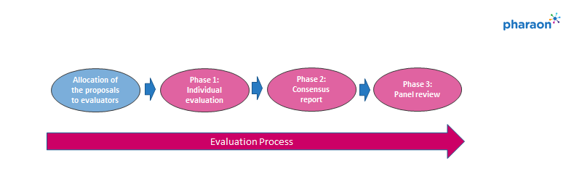
An online seminar will be held on August 22, 2023 to provide training to evaluators on the details of the call, review process, and evaluation expectations.

Payment

Evaluators will be reimbursed for their work based on the number of proposals evaluated with each proposal corresponding to value of 100,00 Eur gross considering 1 hour to evaluate each proposal (max. 10 pages) and for drafting Consensus reports 25,00 EUR gross for each Consensus report. Evaluators should evaluate no more than 10 proposals.

Important notice

Please note that your expression of interest to participate in the PHARAON 2nd Open Call evaluation process as external evaluator is NOT binding in any way and does NOT automatically mean that you will be selected to participate. The final selection of the evaluators will be taken at a later stage as it depends on the number of proposals received and the number of expressions of interest from evaluators.

Indicative timeline

The evaluation will be fully remote and will start on October 3, 2023 (contracting, checking of conflicts of interest and start of individual phase). The consensus phase will take place on October 10, 2023.

Expression of Interest

Please submit your expression of interest by sending email to opencall@pharaon.eu no later than September 4, 2023 and include:
- Brief motivation letter, and
- your CV.

