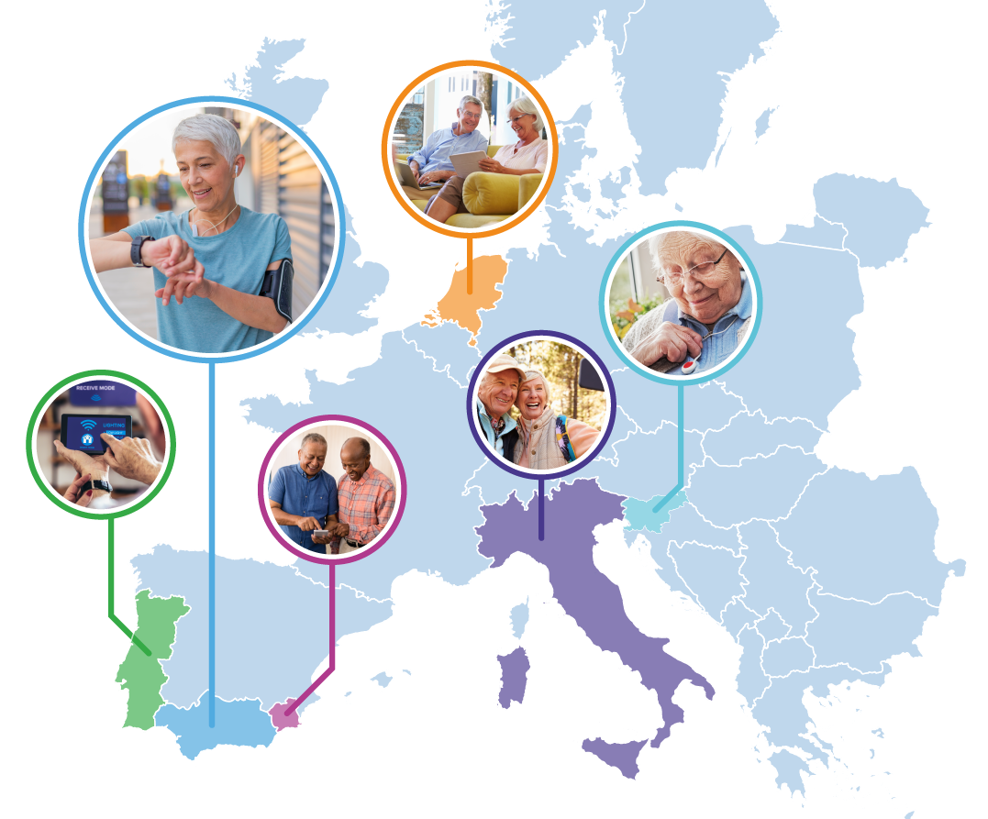
Pilots for Healthy and Active Ageing
Grant Agreement: 857188

Proposal template: Part B - technical content

Introduction
This template is a modified version of the standard Horizon 2020 proposal form for RIA and IA actions.
The structure of this template must be followed when preparing your proposal. It has been designed to ensure that the important aspects of your planned work are presented in a way that will enable the experts to make an effective assessment against the evaluation criteria. Sections 1, 2, and 3 each correspond to an evaluation criterion.
Please be aware that proposals will be evaluated as they were submitted, rather than on their potential if certain changes were to be made. This means that only proposals that successfully address all the required aspects will have a chance of being funded. There will be no possibility for significant changes to content, budget, and consortium composition during grant preparation.
Page limit: The title, list of participants and sections 1, 2 and 3 together, should not be longer than 10 pages. All tables, figures, references, and any other element pertaining to these sections must be included as an integral part of these sections and are thus counted against this page limit.
The page limit will be applied automatically; therefore you must remove this instruction page before submitting.
If you attempt to upload a proposal longer than the specified limit before the deadline, you will receive an automatic warning and will be advised to shorten and re-upload the proposal. After the deadline, excess pages (in over-long proposals/applications) will be automatically made invisible and will not be taken into consideration by the experts. The proposal is a self-contained document. Experts will be instructed to ignore hyperlinks to information that is specifically designed to expand the proposal, thus circumventing the page limit.
Please, do not consider the page limit as a target! It is in your interest to keep your text as concise as possible since experts rarely view unnecessarily long proposals in a positive light.
The following formatting conditions apply.
The reference font for the body text of H2020 proposals is Times New Roman (Windows platforms), Times/Times New Roman (Apple platforms) or Nimbus Roman No. 9 L (Linux distributions).
The use of a different font for the body text is not advised and is subject to the cumulative conditions that the font is legible and that its use does not significantly shorten the representation of the proposal in number of pages compared to using the reference font (for example with a view to bypass the page limit).
The minimum font size allowed is 11 points. Standard character spacing and a minimum of single line spacing is to be used.
Text elements other than the body text, such as headers, foot/end notes, captions, formula's, may deviate, but must be legible.
The page size is A4, and all margins (top, bottom, left, right) should be at least 15 mm (not including any footers or headers).

Fill in the title of your proposal bellow.
TITLE OF THE PROPOSAL

Please provide your administrative details in the table below.
Full legal name of the Applicant (leading partner)
Short name of the Applicant
PIC Number
Full name of the Main Contact Person
Email address of the Main Contact Person
Phone number of the Main Contact Person

Full legal name of the Applicant (partner 1)
Short name of the Applicant
PIC Number
Full name of the Main Contact Person
Email address of the Main Contact Person
Phone number of the Main Contact Person

Full legal name of the Applicant (partner 2)
Short name of the Applicant
PIC Number
Full name of the Main Contact Person
Email address of the Main Contact Person
Phone number of the Main Contact Person

Proposal abstract
Please provide no more than a half page of a concise abstract of the proposal. It has to be clear which one of the Pharaon objectives/topics your proposal is addressing. Please note that this information may be used for dissemination purposes.
Impact

Expected Impact
Please be specific and provide only information that applies to the proposal and its objectives.
Wherever possible, use quantified indicators and targets.
- Describe how your project will contribute to:
- each of the expected impacts mentioned in the Pharaon Open Call, under the relevant objective;
- any substantial impacts not mentioned in the Pharaon Open Call, that would enhance innovation capacity and create new market opportunities;
- Specific Actions (SAs) mentioned in the Pharaon Open Call.
- Describe the proposed communication measures for promoting the project and its findings during the period of the grant. Measures should be proportionate to the scale of the project, with clear objectives. They should be tailored to the needs of different target audiences, including groups beyond the project's own community.

Innovation and technology (Excellence)

Objectives
- Describe the specific objectives for the project, which should be clear, measurable, realistic, and achievable within the duration of the project. It should be clear what Pharaon challenge you are solving and which pilot site(s) you are addressing with your proposal.

Concept and methodology
- Describe and explain the overall concept underpinning the project. Describe the main ideas, models or assumptions involved. Identify any inter-disciplinary considerations and, where relevant, use of stakeholder knowledge. Where relevant, include measures taken for public/societal engagement on issues related to the project. Describe the positioning of the project e.g. where it is situated in the spectrum from ‘idea to application’, or from ‘lab to market’. Refer to Technology Readiness Levels where relevant. (See General Annex G of the work programme).
- Describe and explain the overall methodology.

Ambition/Innovation
- Describe the advance your proposal would provide beyond the state-of-the-art, and the extent the proposed work is ambitious.
- Describe the innovation potential (e.g. ground-breaking objectives, novel concepts and approaches, new products, services or business and organisational models) which the proposal represents. Where relevant, refer to products and services already available on the market.

Implementation
  - Work plan – Work packages, deliverables
Please provide the following:
- brief presentation of the overall structure of the work plan;
- timing of the different tasks and their components (Gantt chart or similar);
- list of tasks with a clear description;
- list of major deliverables;
- (if applicable) graphical presentation of the components showing how they inter-relate (Pert chart or similar).
Table 3.1b: Work plan description
Work package number
Work package title
Person months |  | Start Month |  | End Month
Objectives

Description of work
(including a precise description of tasks)

Milestones, and procedures
- Specify the milestones.
Table 3.2a: List of milestones
Milestone number | Milestone name | Related task(s) (if applicable) | Due date  (in month) | Means of  verification

- Describe any critical risks, relating to project implementation, that the stated project's objectives may not be achieved. Detail any risk mitigation measures. Please provide a table with critical risks identified and mitigating actions.
Table 3.2b: Critical risks for implementation
Description of risk  (indicate likelihood: Low/Medium/High) | Task(s) involved  (if applicable) | Proposed risk  mitigation measures

Operational capacity
Describe competence and experience of the applicant, including its operational resources (human, technical and other) and, if applicable, exceptionally the concrete measures proposed to obtain it by the time of the implementation of the tasks.
Describe your team, including expertise (current and previous) that will be involved in this project. Explain how your team profile matches the expertise needed.

Resources to be committed/Budget
Please attach a detailed calculation in the Excel file – Annex 1 to Part B – Technical Content.
7

Participant | Requested funding €
Requested funding € (up to 200.000 € per action):

Besides the table above, extra information can be provided to support the requested funding.

